Worksheet 1, Minimum Wage and Cost of Living

Minimum Wage and Cost of Living

Part 1: Minimum Wage

A Look at Minimum Wage

  - After watching the TikTok Video, list your observations:

  - Look at the Federal Minimum Wage graph below and list your observations:

  - Do you think you could buy more Big Macs with your salary in 1968 or this year? Why?

Federal Minimum Wage (y-axis is dollars per hour, x-axis is years since 1967)

4
2
0
1
0
2
0
3
0
4
0
5
0
8
6

Part 2: Cost of Living
- Cost of living where the independent variable is the number of years since 1967 and the dependent variable is the amount of money that is worth $100 today.

0
0
0
2
0
4
0
6
0
100
80
60
4
2

- Cost of Living Calculator
Go to the AIER Online Cost of Living Calculator https://bit.ly/31sLlXG
Set the first (or top) year to 2020 and the value to $100. Then change the second (or bottom) year to observe how much money in that year is equal to $100 in 2020.

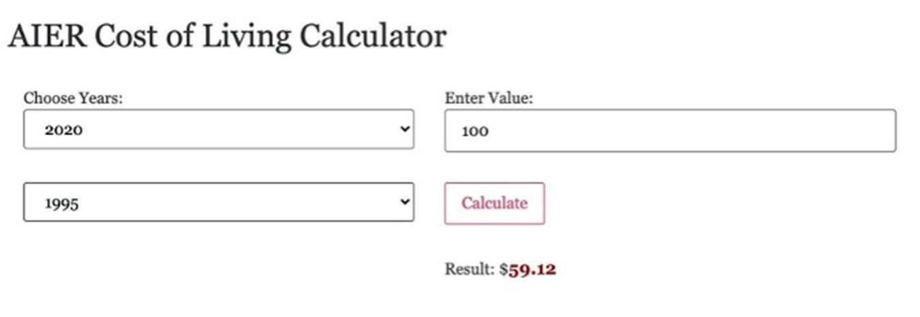
Figure 1. AIER Cost of Living Calculator
Source: https://www.aier.org/cost-of-living-calculator/

Use the Cost of Living Graph (#3) or the Cost of Living Calculator (#4) to answer the following questions listed below.
Note that the x-axis is years since 1967. (So x = 1 is the year 1968). The last data point is from 2020.

  - What is slope? What are some ways we find it? Is there more than one method?

  - What is the slope of the line between the points with x-values 1968 and 2020?

  - What is the slope of the line between the points with x-values 1968 and 1974? Interpret the slope (what does this mean in terms of cost of living?).

Choose any two points (more than 2 years apart) on the graph and draw a line segment joining them. Points chosen:

  - Find the slope of your line segment.

  - Investigate the historical importance during that time frame. Describe any connections between the graph and the historical events you found.

  - Summarize your findings in a presentation to share with your class. Include how you found the slope and the historical connections.

Summary: For each group that presents, respond to the following prompts.
  - What time frame did the group choose? What was the slope of their line?

  - Did the group use the same method as your group for finding the slope? If not, how did they find the slope?

  - What was similar to your observations and your peers’ observations? What was different?

  - List observations from your peers’ presentations. What surprised you?

  - Do you agree/disagree with the connections your peers found?

