Teacher Resource 1, Answer Key for Worksheet 1

Answer Key for Worksheet 1

The rubric below can be used to grade the letter students will write in the Taking Action step of the lesson. If you choose to use this rubric, we recommend you give it to students along with the letter-writing prompt.

70%+ | 80%+ | 90%+
- 6 complete sentences  - Defines income inequality in their own words | - 2 paragraphs  - Suggests a solution we can do as a class to address income inequality | - Begins to take action on fixing income inequality

Solutions:

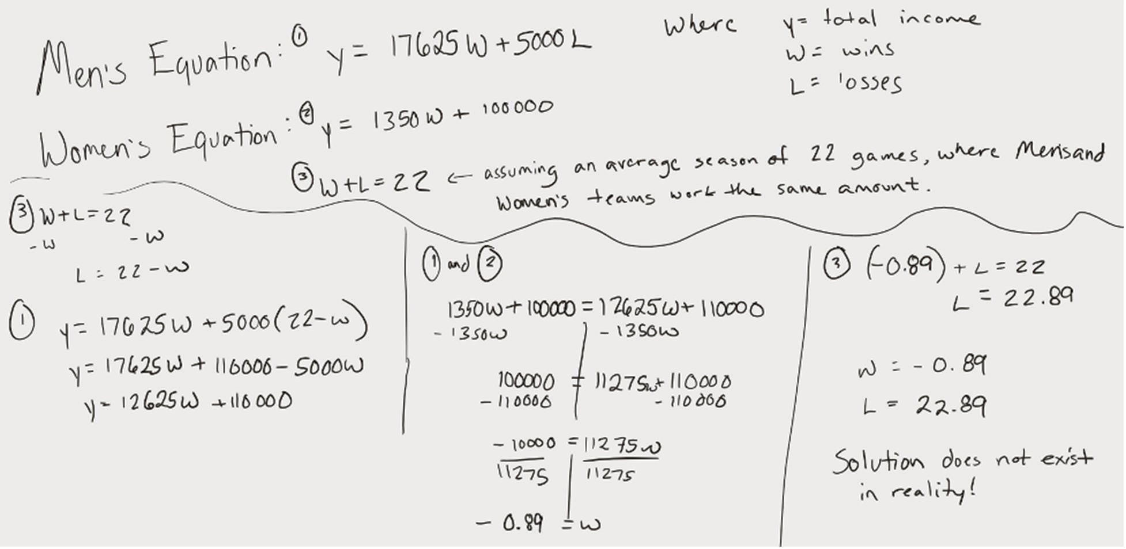

Retrieved from the companion website for Middle School Mathematics Lessons to Explore, Understand, and Respond to Social Injustice by Basil M. Conway IV, Lateefah Id-Deen, Mary C. Raygoza, Amanda Ruiz, John W. Staley, Eva Thanheiser, and Brian R. Lawler. Thousand Oaks, CA: Corwin, www.corwin.com. Copyright © 2023 by Corwin Press, Inc. All rights reserved. Reproduction authorized for educational use by educators, local school sites, and/or noncommercial or nonprofit entities that have purchased the book.

