Worksheet 2, Considering the Fairness of Missouri’s Voting District Boundaries

Considering the Fairness of Missouri’s Voting District Boundaries

In Missouri, based on the 2016 and 2020 presidential elections, about 57% of Missourians vote Republican. As of January 2021, 6 of Missouri’s 8 U.S. representatives are Republican. (Consider contextual changes and/or updates.)

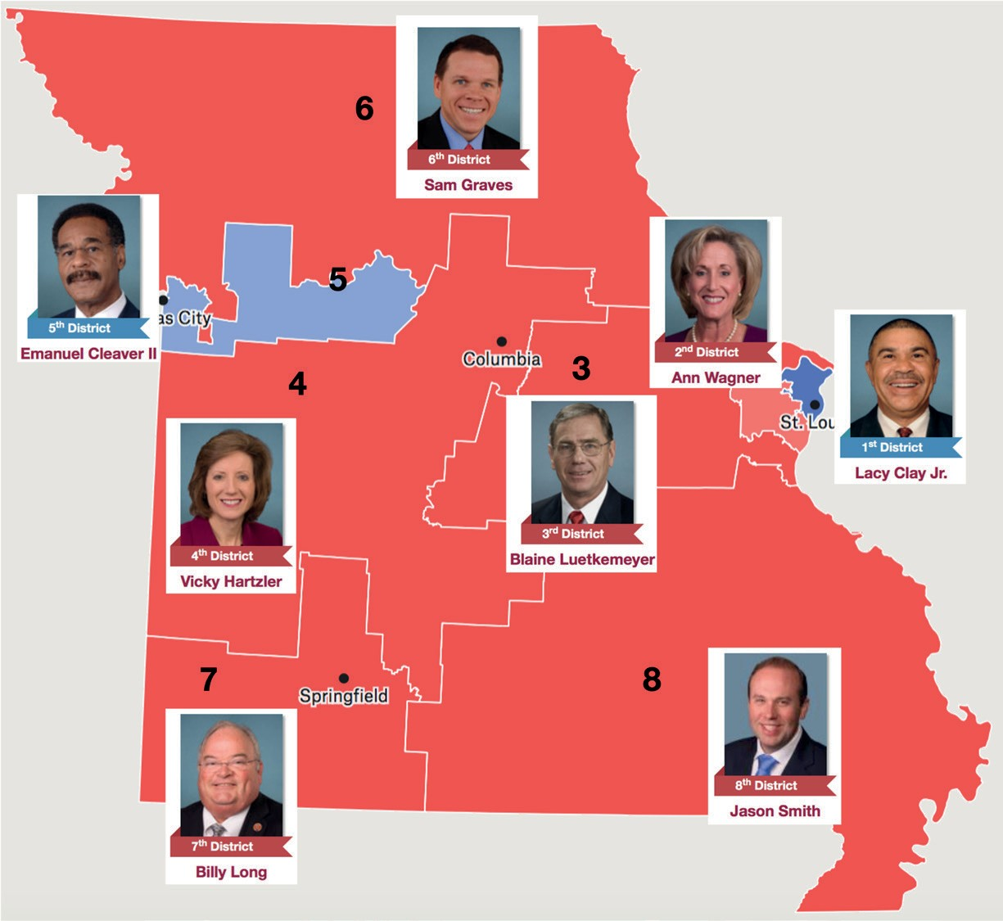
Source: 2012 Congressional Map from Missouri Secretary of State, www.sos.mo.gov. Missouri Congress Members from www.congress.gov.

Is this OK? The politicians who draw the voting districts would probably never admit it if they had cheated, so how could we tell?

- Today’s challenge: Create a measure that quantifies the fairness of voting district boundaries. The application of your measure to a voting situation should result in a clear conclusion of either “cheating” or “not cheating.”

- Use the data in Table 1 below from Missouri’s 2020 election of U.S. representatives to try out your measure. (Consider contextual changes and/or updates)
Table 1
2020 Missouri U.S. Congressional Districts

2020 Missouri U.S. Congressional Districts
District | Republican | Democrat
1 | 59,940 | 249,087
2 | 233,157 | 204,540
3 | 282,866 | 166,095
4 | 245,247 | 107,635
5 | 135,934 | 207,180
6 | 258,709 | 118,926
7 | 254,318 | 98,111
8 | 253,811 | 70,561

- What questions or “wonderings” do you have after working on this task?

Optional workspace:

