Teacher Resource 1, Gerrymandering of Voting Districts Task (Answer Key)

Gerrymandering of Voting Districts Task (Answer Key)

- How many of the 5 representatives would you expect to come from the north side? Why?
Potential response: “2 representatives should come from the north side (green team) because 20 out of the 50 people are on the north side, and each group of 10 people gets 1 representative. Since two-fifths of the people are on the north side, two-fifths of the representatives should too.”



- Can you group them so that all representatives come from the south side? Would that be fair? Potential response(s):
“You could draw the blocks so that each one has 6 south-siders (gray team members).” “That wouldn’t be fair since the north side (green team) would have no representation.”
“It might be disappointing for the north side that they do not have any representatives, but that would not be unfair because the majority of the community is on the south side.”
“If they got just one representative, then it should be from the south side since that’s the majority. But they get 5 representatives, so 2 should come from the north side.”

3a. Can you group them so that more representatives come from the north side than the south side?

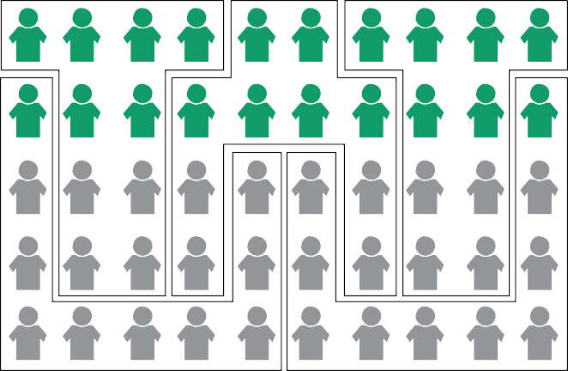
3b. What do you notice about the groups in the drawing that allows the north side to have more representatives?
Potential response: “When the green team wins, it barely wins (6 to 4). When the gray team wins, it wins by a land- slide (9 to 1).”
Teacher note: This is accomplished by “cracking” and “packing.” “Cracking” refers to breaking up blocks of like- minded voters to dilute the strength of their voice. “Packing” refers to concentrating like-minded voters together to create as many “wasted” votes as possible.
3c. Would that grouping be fair? Why or why not?
Potential response: “No, this way of drawing the groups leads to the north side being over represented.”

