Worksheet 3, What Is Fair?

Name:

What Is Fair?

In Worksheet 1, you modeled how you think money is divided. In Worksheet 2, you modeled how money is typically divided. Now, think about what is fair. How should money be allocated?
- Divide $100 among the eight categories in a way that you think is fair. Color in the bill and label the key.

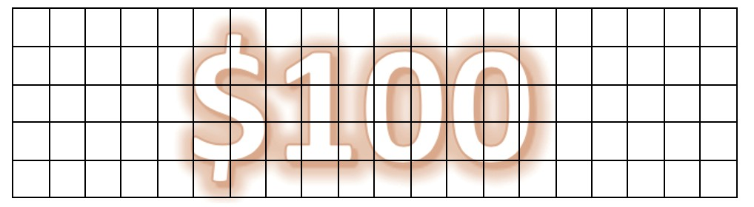

Materials: % Retailer: %
Factory profit: % Intermediary costs: % Transport: % Brand profit: %
Overhead cost: % Workers: %
- Why do you allocate the money in this way?

- How does this new allocation differ from the previous two versions?

- What questions do you have about allocating money among the eight categories involved in the production process?

Retrieved from the companion website for Middle School Mathematics Lessons to Explore, Understand, and Respond to Social Injustice by Basil M. Conway IV, Lateefah Id-Deen, Mary C. Raygoza, Amanda Ruiz, John W. Staley, Eva Thanheiser, and Brian R. Lawler. Thousand Oaks, CA: Corwin, www.corwin.com. Copyright © 2023 by Corwin Press, Inc. All rights reserved. Reproduction authorized for educational use by educators, local school sites, and/or noncommercial or nonprofit entities that have purchased the book.

