Worksheet 2, How Is Money Allocated?

Name:

How Is Money Allocated?

- Your teacher has now shown you how money from an item is typically divided. On the $100 bill below, show how the money is actually allocated.
Materials: 12% Retailer: 58%
Factory profit: 4% Intermediary costs: 4%
Transport: 8% Brand profit: 12.4%
Overhead cost: 1% Workers: 0.6%

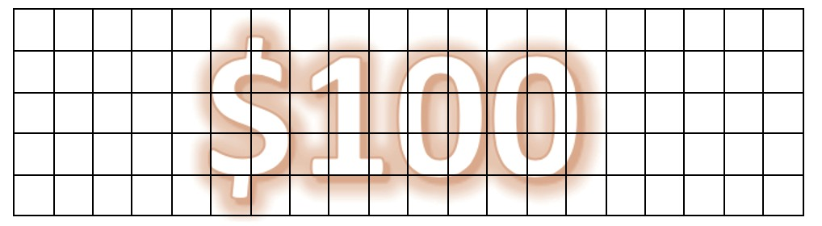

- If a shirt costs $29, and not $100, how much money is allocated to each category involved in the production process based on the percentages in Question 1?

- Compare and contrast how the money is allocated in your models (Worksheet 1) versus in the model above (Question 1).

Retrieved from the companion website for Middle School Mathematics Lessons to Explore, Understand, and Respond to Social Injustice by Basil M. Conway IV, Lateefah Id-Deen, Mary C. Raygoza, Amanda Ruiz, John W. Staley, Eva Thanheiser, and Brian R. Lawler. Thousand Oaks, CA: Corwin, www.corwin.com. Copyright © 2023 by Corwin Press, Inc. All rights reserved. Reproduction authorized for educational use by educators, local school sites, and/or noncommercial or nonprofit entities that have purchased the book.

