Worksheet 1, How Should Money Be Allocated?

Name:

How Should Money Be Allocated?

Imagine that you buy an item of clothing from the store for $100. How should the money be allocated?
- Who and what is involved in the t-shirt-making process? Create a key matching a color to each category involved in the production process that we discussed as a class.

Key:

- The $100 bill below has been subdivided into 100 equal sections, where each section is worth $1. How do you think the money is divided among the eight categories?
  - Divide the bill among the categories by coloring in the sections on the $100 bill.

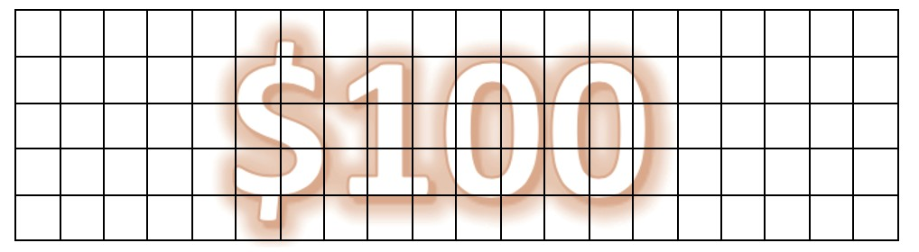

- Discuss how you divided your bill with your group.
  - Are you in agreement with what others said?
  - What differed?
  - If you could change anything in your drawing, what would you change?
Summarize your discussion here.

Retrieved from the companion website for Middle School Mathematics Lessons to Explore, Understand, and Respond to Social Injustice by Basil M. Conway IV, Lateefah Id-Deen, Mary C. Raygoza, Amanda Ruiz, John W. Staley, Eva Thanheiser, and Brian R. Lawler. Thousand Oaks, CA: Corwin, www.corwin.com. Copyright © 2023 by Corwin Press, Inc. All rights reserved. Reproduction authorized for educational use by educators, local school sites, and/or noncommercial or nonprofit entities that have purchased the book.

