Worksheet 3, The Billionaire Complex

The Billionaire Complex

Part 1
Article 1: “Uber, Other Gig Companies Spend Nearly $200 Million to Knock Down an Employment Law They Don’t Like—and it Might Work” (https://wapo.st/3EvyhiA)
Article 2: “Uber and Lyft Used Sneaky Tactics to Avoid Making Drivers Employees in California, Voters Say. Now, They’re Going National” by Faiz Siddiqui and Nitasha Tiku (https://wapo.st/3plyEGm)
In small groups, discuss the following questions:
- The campaign for No on Prop 22 was outspent by Yes on Prop 22 $200,000,000 to $20,000,000. Why would compa- nies like Uber, Lyft, etc. spend so much money to campaign for limiting the benefits and compensation of drivers?
- How does maintaining drivers as contractors rather than employees benefit these companies?
- How could the $200,000,000 spent on the campaign be proportioned to benefit the drivers? (Show your answer using proportional reasoning and unit conversions.)
- Although the passing of Prop 22 in November 2020 impacted California drivers, Uber made a national announce- ment in April 2021 that stated there would be a $250 million incentive program to boost driver earnings and encour- age drivers to return to the company. How do these two actions conflict with one another?

Part 2
Your teacher will place your class into 10 small groups. Each group will randomly select a number between 1 and 10. That number will represent the placement of the billionaire on the Top 10 US Billionaires list we previously created. Your group will then research the billionaire and the source of their wealth.
In your small groups, research the following:

About the Billionaire | About the Billionaire’s Organization/Corporation
- Full name  - Hometown  - Education  - Average salary  - Net worth  - Philanthropic efforts  - Headshot  - Any childhood information (parents/ caretakers, siblings, etc.) | - Full name  - Location of headquarters  - Number of locations in the US and worldwide  - Size of organization/corporation  - How is revenue generated?  - Net worth  - Philanthropic efforts  - Company’s logo and slogan

Part 3
The COVID-19 pandemic has exposed a number of inequalities throughout the United States of America. From health care to housing, many Americans have suffered greatly—however, not all Americans. It has been documented that the wealth of the U.S. billionaires grew during the first 9 months of the COVID-19 pandemic. The chart below demonstrates how income inequality gaps have grown further. In your small group, answer the following questions. Summarize your discussion in a written response to submit and share.

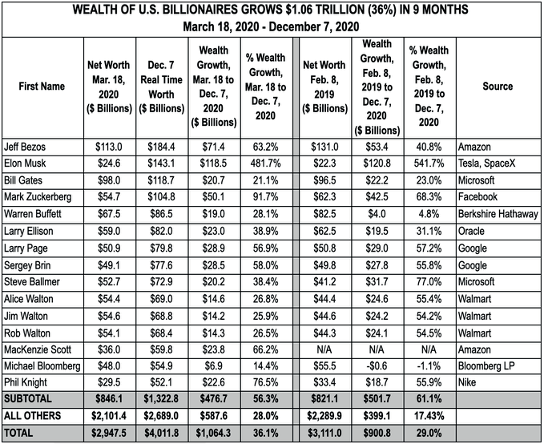

Sources: March 18, 2020 data: Forbes, “Forbes Publishes 34th Annual List Of Global Billionaires,” March 18, 2020. Dec. 7, 2020 data: Forbes, “The World’s Real-Time Billionaires, Today’s Winners and Losers,” accessed Dec. 8, 2020. Feb. 8, 2019 data: Forbes 2019 World Billionaires Report, March 5, 2019.

All data in table is from Forbes and available in an Excel document downloadable at resources.corwin.com/TMSJ- middleschool
- What factors contributed to the growth Jeff Bezos (and MacKenzie Scott) saw during the first nine months of the COVID-19 pandemic?
- What factors contributed to Elon Musk’s 481.7% wealth growth from March 19 to December 7, 2020?
- Based on what you learned about the philanthropic efforts of these individuals and their companies, what are some other measures they can take to help ease the suffering many Americans have faced due to the COVID-19 pan- demic?
  - What are some steps they can take within their companies to support their employees and the communities they serve?
- What local issues (expansions, closures, etc.) have you seen that could be related to the growth of these companies? What can you do to help local stores and businesses?

