Worksheet 2, Top 10 Billionaires

Top 10 Billionaires

Part 1
- Look at the Top 10 billionaires in the world. What percent are from the United States? This information can be found at the Forbes website “Real Time Billionaires” (https://bit.ly/3lw2Aym).

Part 2
- Who are the top 10 US billionaires presented on the current Forbes list? Complete the table below with the follow- ing information. Discuss the similarities and differences between these individuals.

TOP 10 US BILLIONAIRES

 | Name | Source | Net Worth & Daily Rate | Age | Race & Gender
1 |  |  | Net Worth:
1 |  |  | Daily Rate:
2 |  |  | Net Worth:
2 |  |  | Daily Rate:
3 |  |  | Net Worth:
3 |  |  | Daily Rate:
4 |  |  | Net Worth:
4 |  |  | Daily Rate:
5 |  |  | Net Worth:
5 |  |  | Daily Rate:
6 |  |  | Net Worth:
6 |  |  | Daily Rate:
7 |  |  | Net Worth:
7 |  |  | Daily Rate:
8 |  |  | Net Worth:
8 |  |  | Daily Rate:
9 |  |  | Net Worth:
9 |  |  | Daily Rate:
10 |  |  | Net Worth:
10 |  |  | Daily Rate:

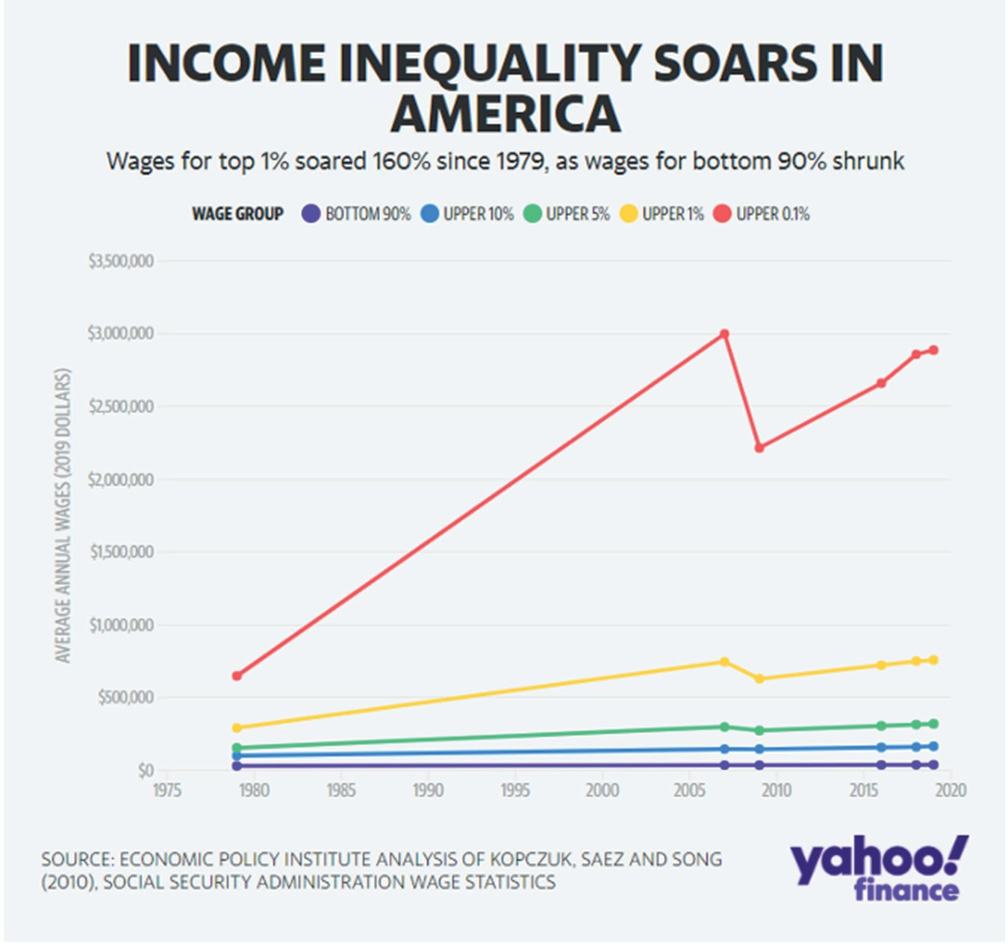

View this graph online to experience the interactive features: https://bit.ly/SJIncomeInequality

Read and analyze the information provided on the Income Inequality Soars in America graph. Answer the following questions based on the information you have drawn from this activity and the graph above.
- One objective for this lesson is to work with friends, family, and community members to make our world fairer for everyone. This graph demonstrates income inequality in America. What measures can you take to bring awareness to income inequality in your home, school, and community?
- What key events occurred from 2007 to 2009 that contributed to the major drop for the Upper 0.1%?
- There are politicians who are pushing for greater taxes on the individuals represented in the Upper 0.1% (red line) and Upper 1% (yellow line) to afford measures that will provide relief for those negatively impacted by the COVID- 19 pandemic. Do you believe that is fair? Why or why not? Be sure to get a response from each member of your group while actively listening to their responses without judgment or ridicule.

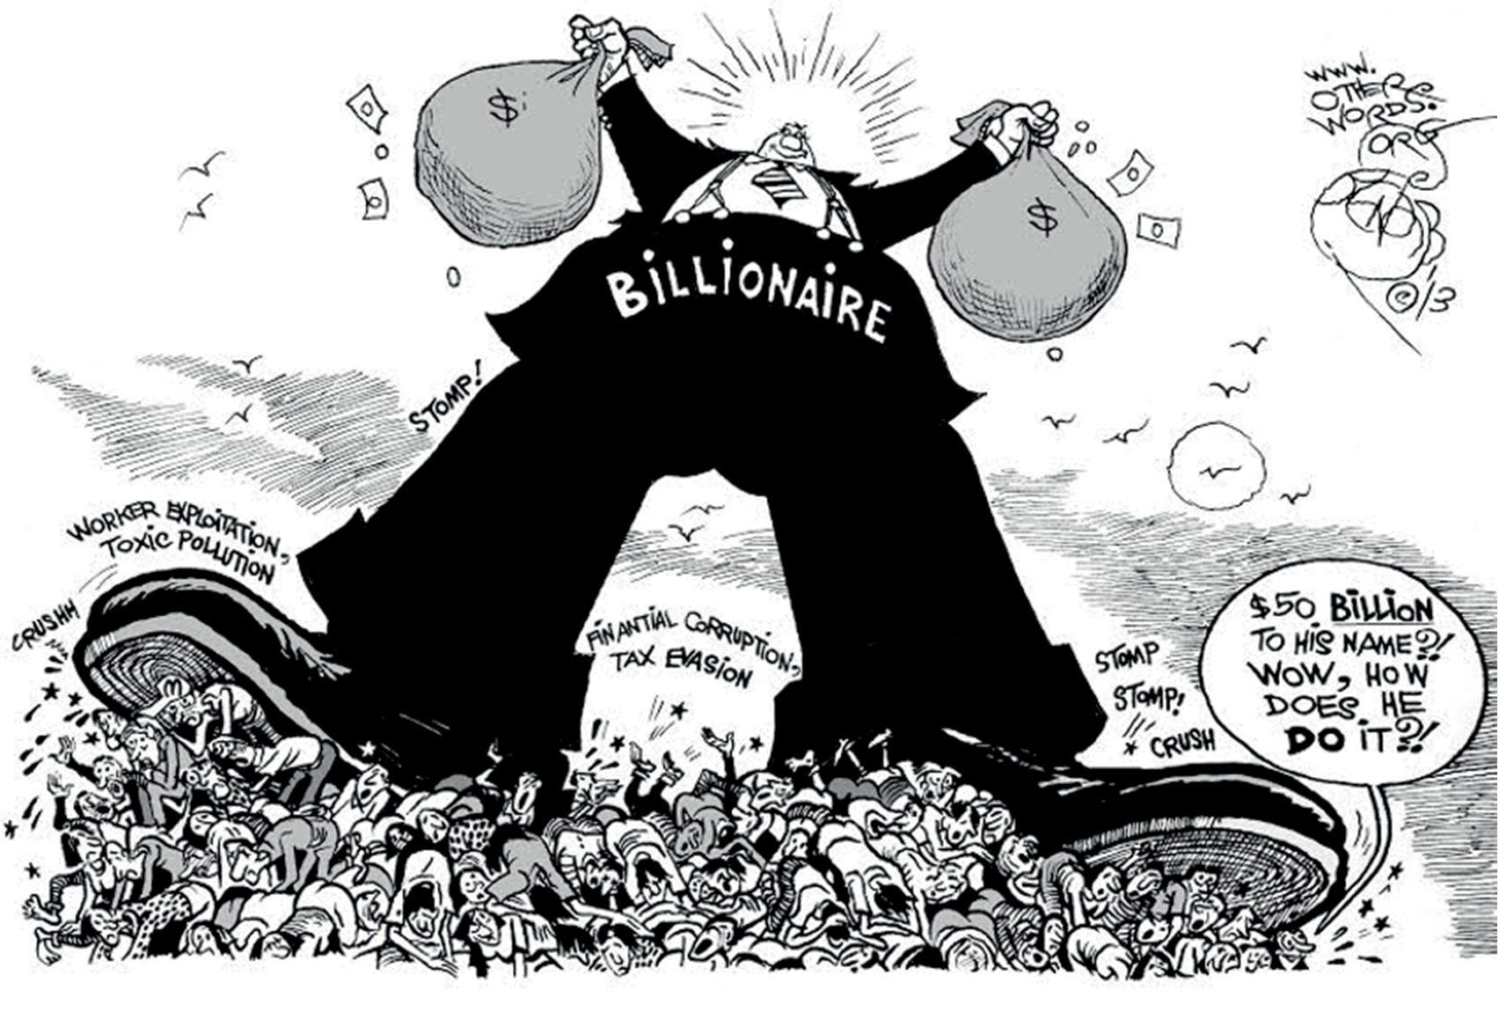

Source: “How to Become a Billionaire” created by Khalil Bendib, OtherWords.org (2013). No changes made; misspelling of “fi ial” in original. https://otherwords.org/ how-to-become-billionaire-cartoon/ CC BY 3.0 https://creativecommons.org/licenses/by/3.0/

Write a brief response to the following questions:
- What is the point of the political cartoon?
- What techniques does the cartoonist employ to deliver the cartoon’s message? (Common techniques used in politi- cal cartoons include symbols, words, caricature, exaggeration, and irony.)
  - Which technique is the most effective in communicating the message? How does this political cartoon connect to the lesson?

