Worksheet 2, Grocery Trek

Grocery Trek

Akeelah’s family loved her gumbo so much that they asked her to cook for her uncle’s birthday coming up a month after Nana’s. You live right next to Akeelah on 3rd St. and La Salle Ave., and you offer to go with her to help her carry the grocer- ies. It’s a nice day out and you two decide to walk the distance (or use wheelchairs if you use one). First, she wants to go to Foods Co. on Williams Ave. and Apollo St. to get chicken and the ingredients for salad and cake. She wants to stop and get a slice of pizza at All Nite Pizza for lunch. She also plans to buy special BBQ sauce for the chicken at Let’s Eat BBQ and More on 3rd St. and Revere St.
Akeelah wants to run these errands on Saturday at 11 a.m. You volunteer, helping with sports games and arts and crafts for younger students, at Leola M. Havard Early Education School at 12:30 p.m. on Saturdays. Taking into consideration the time you will spend at each store, will you have enough time to go with Akeelah to help her carry the groceries home and still make it to Leola M. Havard Early Education School by 12:30 in the afternoon?

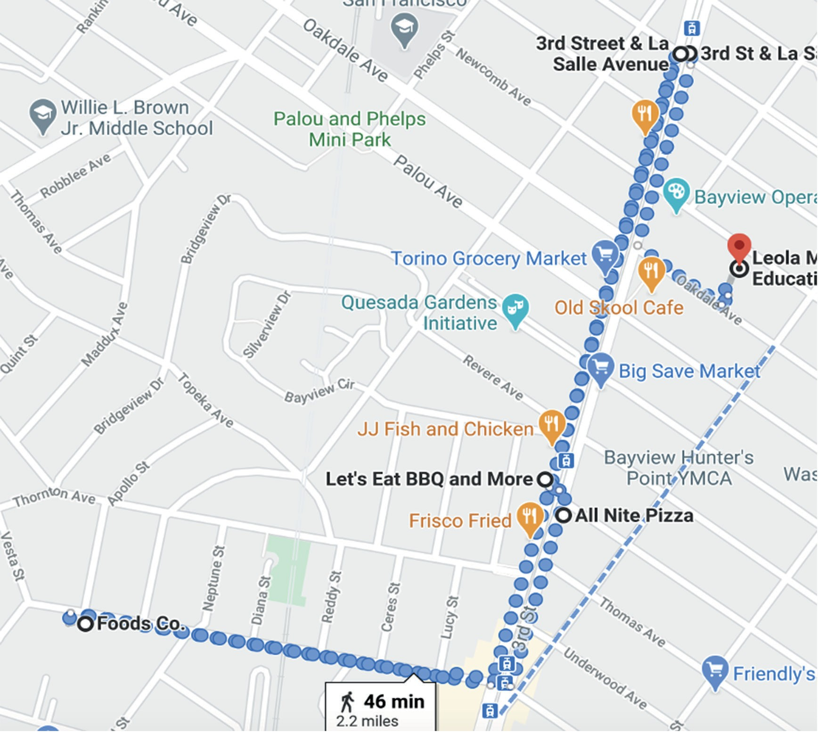
Source: Map data ©2021 Google

Part 1: Google Maps estimates
Google Maps estimates that the distance is 2.2 miles and the time to walk it would be 46 minutes.
- According to this estimate, how long does Google assume it takes to walk 1 mile? Keep in mind, some people use addi- tional methods of transportation (e.g., wheelchairs).

- How many feet per second would this be?

Part 2: Finding your own travel rate
Discuss and decide as a team how to find your own travel rate or speed. Your teacher will give you a measuring tape and timer. You may walk, use a wheelchair, or other means of travel.
Some suggestions: a) You can travel a fixed distance and time yourself. b) You can travel a fixed time and measure the dis- tance you travel. c) When you do this you may want to measure your rate several times and find the mean or average. d) Do you know how long it is from school to home? How long does it take you to travel the distance?

- What is your average travel rate?

- How long would it take you to travel 2.2 miles?

- How long are you staying at each location? Will you be able to make it to the school on time?
  - From Akeelah’s house on 3rd St. and La Salle Ave. to Foods Co. on Williams Ave. and Apollo St. is 0.9 miles. From Foods Co. on Williams Ave. and Apollo St. to All Nite Pizza on 3rd St. and Shafter Ave. is 0.5 miles.
  - From All Nite Pizza on 3rd St. and Shafter Ave. to Let’s Eat BBQ and More on 3rd St. and Revere St. is 180 feet.
  - From Let’s Eat BBQ and More on 3rd St. and Revere St. to Akeelah’s house on 3rd St. and La Salle Ave. is 0.4 miles.
  - From Akeelah’s house on 3rd St. and La Salle Ave. to Leola M. Havard Early Elementary School on Oakdale between 3rd St. and Lane St. is 0.3 miles.

Optional Extension Questions:
- What if you decided to run from home to the school after you drop off the groceries at Akeelah’s house?

- How long would it take someone with a wheelchair (or someone with a walker or crutches) to travel 2.2 miles? What else might you need to consider?

- How long would it take to travel 2.2 miles on a scooter, skateboard, or bike? How could you figure this out?

- Is there a different route you could take? How long would it take you?

- Trying it out! If there is time, and if your teacher invites you to, travel the route to test out your calculations. What did you notice and learn? What edits or accommodations may you need to make to your route?

Part 3: Steps tracker
- Akeelah has been keeping track of her steps with a steps tracker. If you also walk, you decide to also track your steps while you get the groceries. How many steps will you take walking 2.2 miles? You and/or others may travel using a wheel- chair, crutches, or other means and may not count “steps.” What may be of interest to explore for people who use wheel- chairs or other means of transportation?

Part 4: Self-reflection
- How do you feel about needing to travel this distance and visit multiple stores to purchase groceries? How might this affect others in the community? You will consider actions to take in the “A Call to Action” next.

Optional Part 5: Graphing distance versus time for the trip
- Graph distance versus time for your and Akeelah’s trip. What does the graph look like while you are not traveling (e.g., waiting in line at the grocery store)?

