Cor(o)ner Store: Where Healthy Food Comes to Die . . .

Name:

Which does not belong?

Look at the pictures below. Identify each of the pictures and decide WHICH does not belong and WHY?

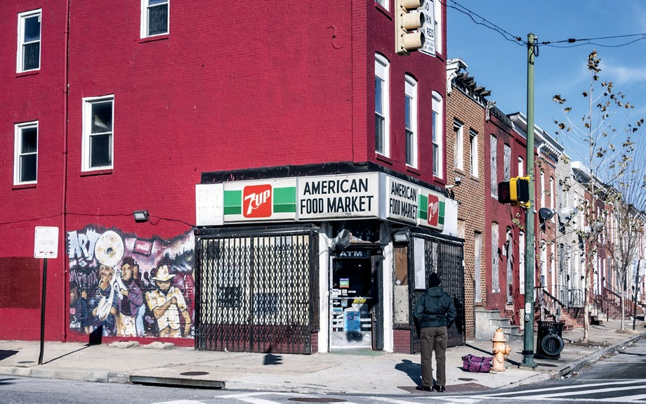
Source: peeterv/iStock.com

Worksheet 1, Cor(o)ner Store: Where Healthy Food Comes to Die . . .
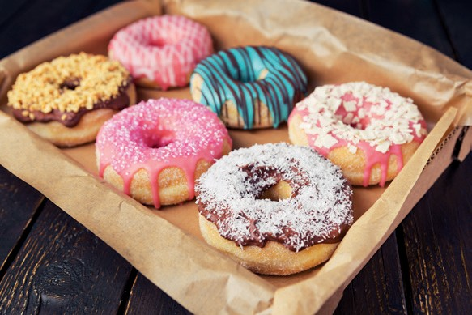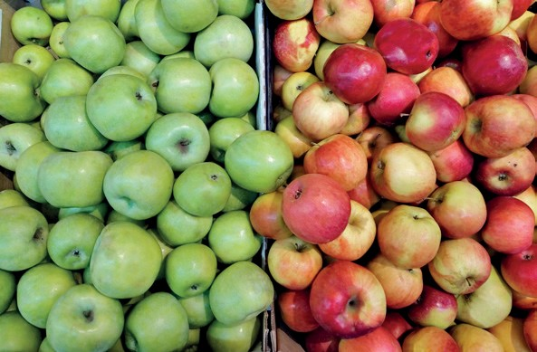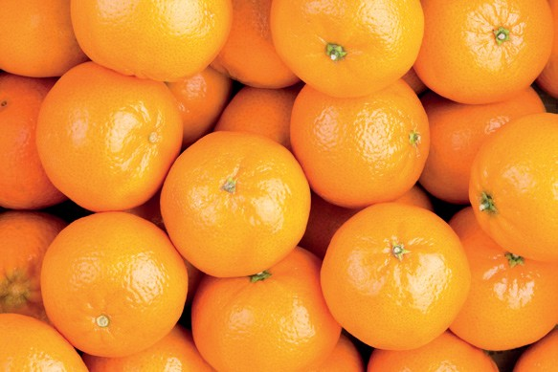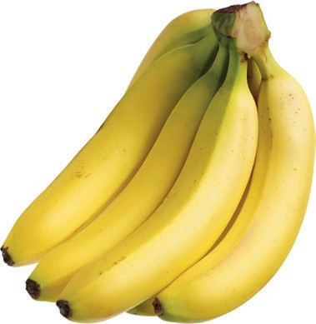
Source: donuts from sara_winter/iStock.com; apples from alex55/iStock.com; oranges from Ozgur Coskun/iStock.com; bananas from chengyuzheng/iStock.com

Read the following vocabulary words BEFORE watching the video.
Food Apartheid (Desert): area in which it is difficult to access affordable and healthy food, often in an urban area.
Corner Store: a non-traditional store that sells many necessities. They are normally located on the corner, and they sell a range of items from toiletries; drinks (non-alcoholic and alcoholic); food (normally not fresh food, mainly pre-packaged); cigarettes; and lotto tickets. The items in the store are often two to three times more expensive than in a traditional store and are often non-name-brand items, with the exception of cigarettes and drinks.
Coroner: a public official whose job is to find out the cause of death when people die in ways that are violent, sudden, etc.

Watch YouTube Video: Eliminating Food Apartheids (Deserts) in America

What are some of your FIRST thoughts about what is referred to as “food deserts”? Why would they exist? What are some potential challenges people of these communities might face? How do you feel about this? Record your thoughts and feelings.

AKEELAH’S SEARCH FOR FRESH SEAFOOD
Akeelah wants to make a special dinner for her Nana on her 70th birthday. She decides to try an old family recipe for gumbo. Gumbo, a dish that Akeelah’s Nana loved as a child back in New Orleans, calls for fresh ingredients for the recipe. Where Akeelah lives there is limited access to a traditional grocery store (a store that sells a variety of food and goods to the public) or fresh food, like the crab, okra, or shrimp in the gumbo she will make. She often has to travel outside of her neighborhood to get the groceries that she really needs. Akeelah is determined to make this meal for her grandmother.

Think. Pair. Share.

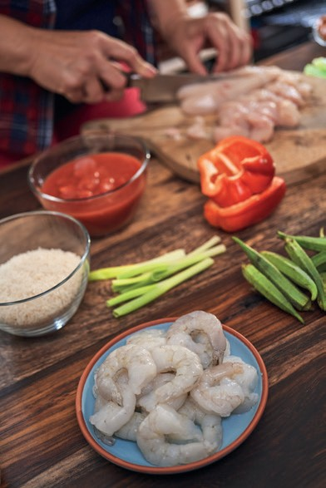
Source: GMVozd/iStock.com

What do you think about Akeelah’s access to fresh food/traditional grocery stores? Do you think that it is fair? What issues might this cause Akeelah and her family or other people in her community? What questions do you have?

Math Thinking: (After reading the Task Card, use this space to develop your math thinking.)

SELF-REFLECTION
Write a reflection on how her trip might affect her health, nutrition, quality of life, and feelings about her neighborhood. After constructing Akeelah’s journey and consider- ing what you learned from the videos and vocabulary words, reflect some of the following questions:
- How might her trip affect her health (physical or emotional)?
- How might her trip affect her nutrition or quality of life?
- What does this trip say about where she lives?
- Do you think that this trip is typical for Akeelah or people in her community?
- What questions would you have for Akeelah?

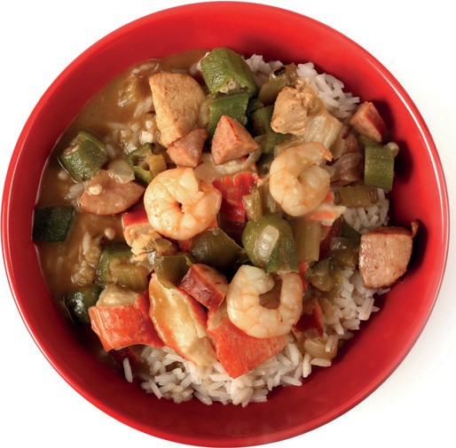
Source: pamela_d_mcadams/iStock.com

- What actions could you take (with your classmates, teachers, neighbors, family, friends, community members) to bring fresh food to Akeelah’s community?

Why do you think the authors called this activity “Cor(o)ner Store”? Use the definitions provided above to help support your ideas.

RECIPE CARD

Ingredients
- 1 cup all-purpose flour
- 1 cup coarsely chopped celery
- 1 large onion, coarsely chopped
- 1 large green bell pepper, coarsely chopped
- 2 cloves garlic, minced
- 1 pound andouille sausage, sliced
- 3 quarts water
- 6 cubes beef bouillon
- 1 tablespoon white sugar
- salt to taste
- 2 tablespoons hot pepper sauce (such as Tabasco®), or to taste

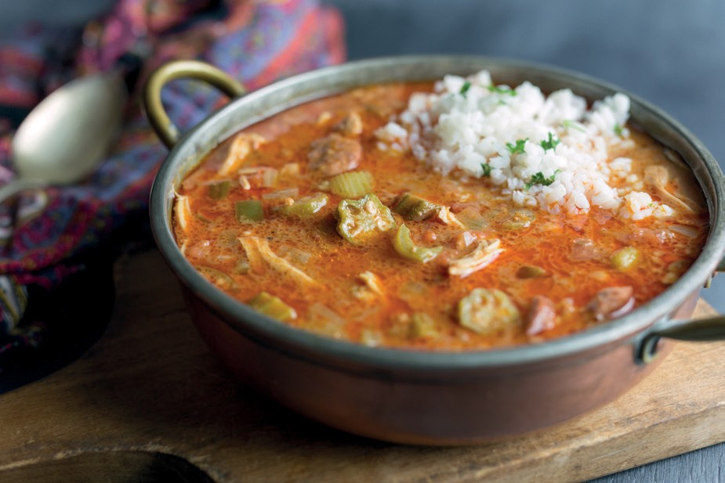
Source: AimeeLeeStudios/iStock.com

- 1 teaspoon Cajun seasoning blend (such as Tony Chachere’s®), or to taste
2
- 4 bay leaves
- 1 teaspoon dried thyme leaves
2
- 1 (14.5 ounce) can stewed tomatoes
- 1 (6 ounce) can tomato sauce
- 4 teaspoons gumbo filé powder, divided
- bacon drippings
- 2 (10 ounce) packages frozen cut okra, thawed
- 2 tablespoons distilled white vinegar
- 1 pound lump crabmeat
- 3 pounds uncooked medium shrimp, peeled and deveined
- 2 tablespoons Worcestershire sauce
This recipe comes from Reasor’s Creole Gumbo (https://bit.ly/3ptb36H).

