Teacher Resource 1, Image of Complete Grocery Store Map (Day 1)

Image of a Complete Grocery Store Map (Day 1)

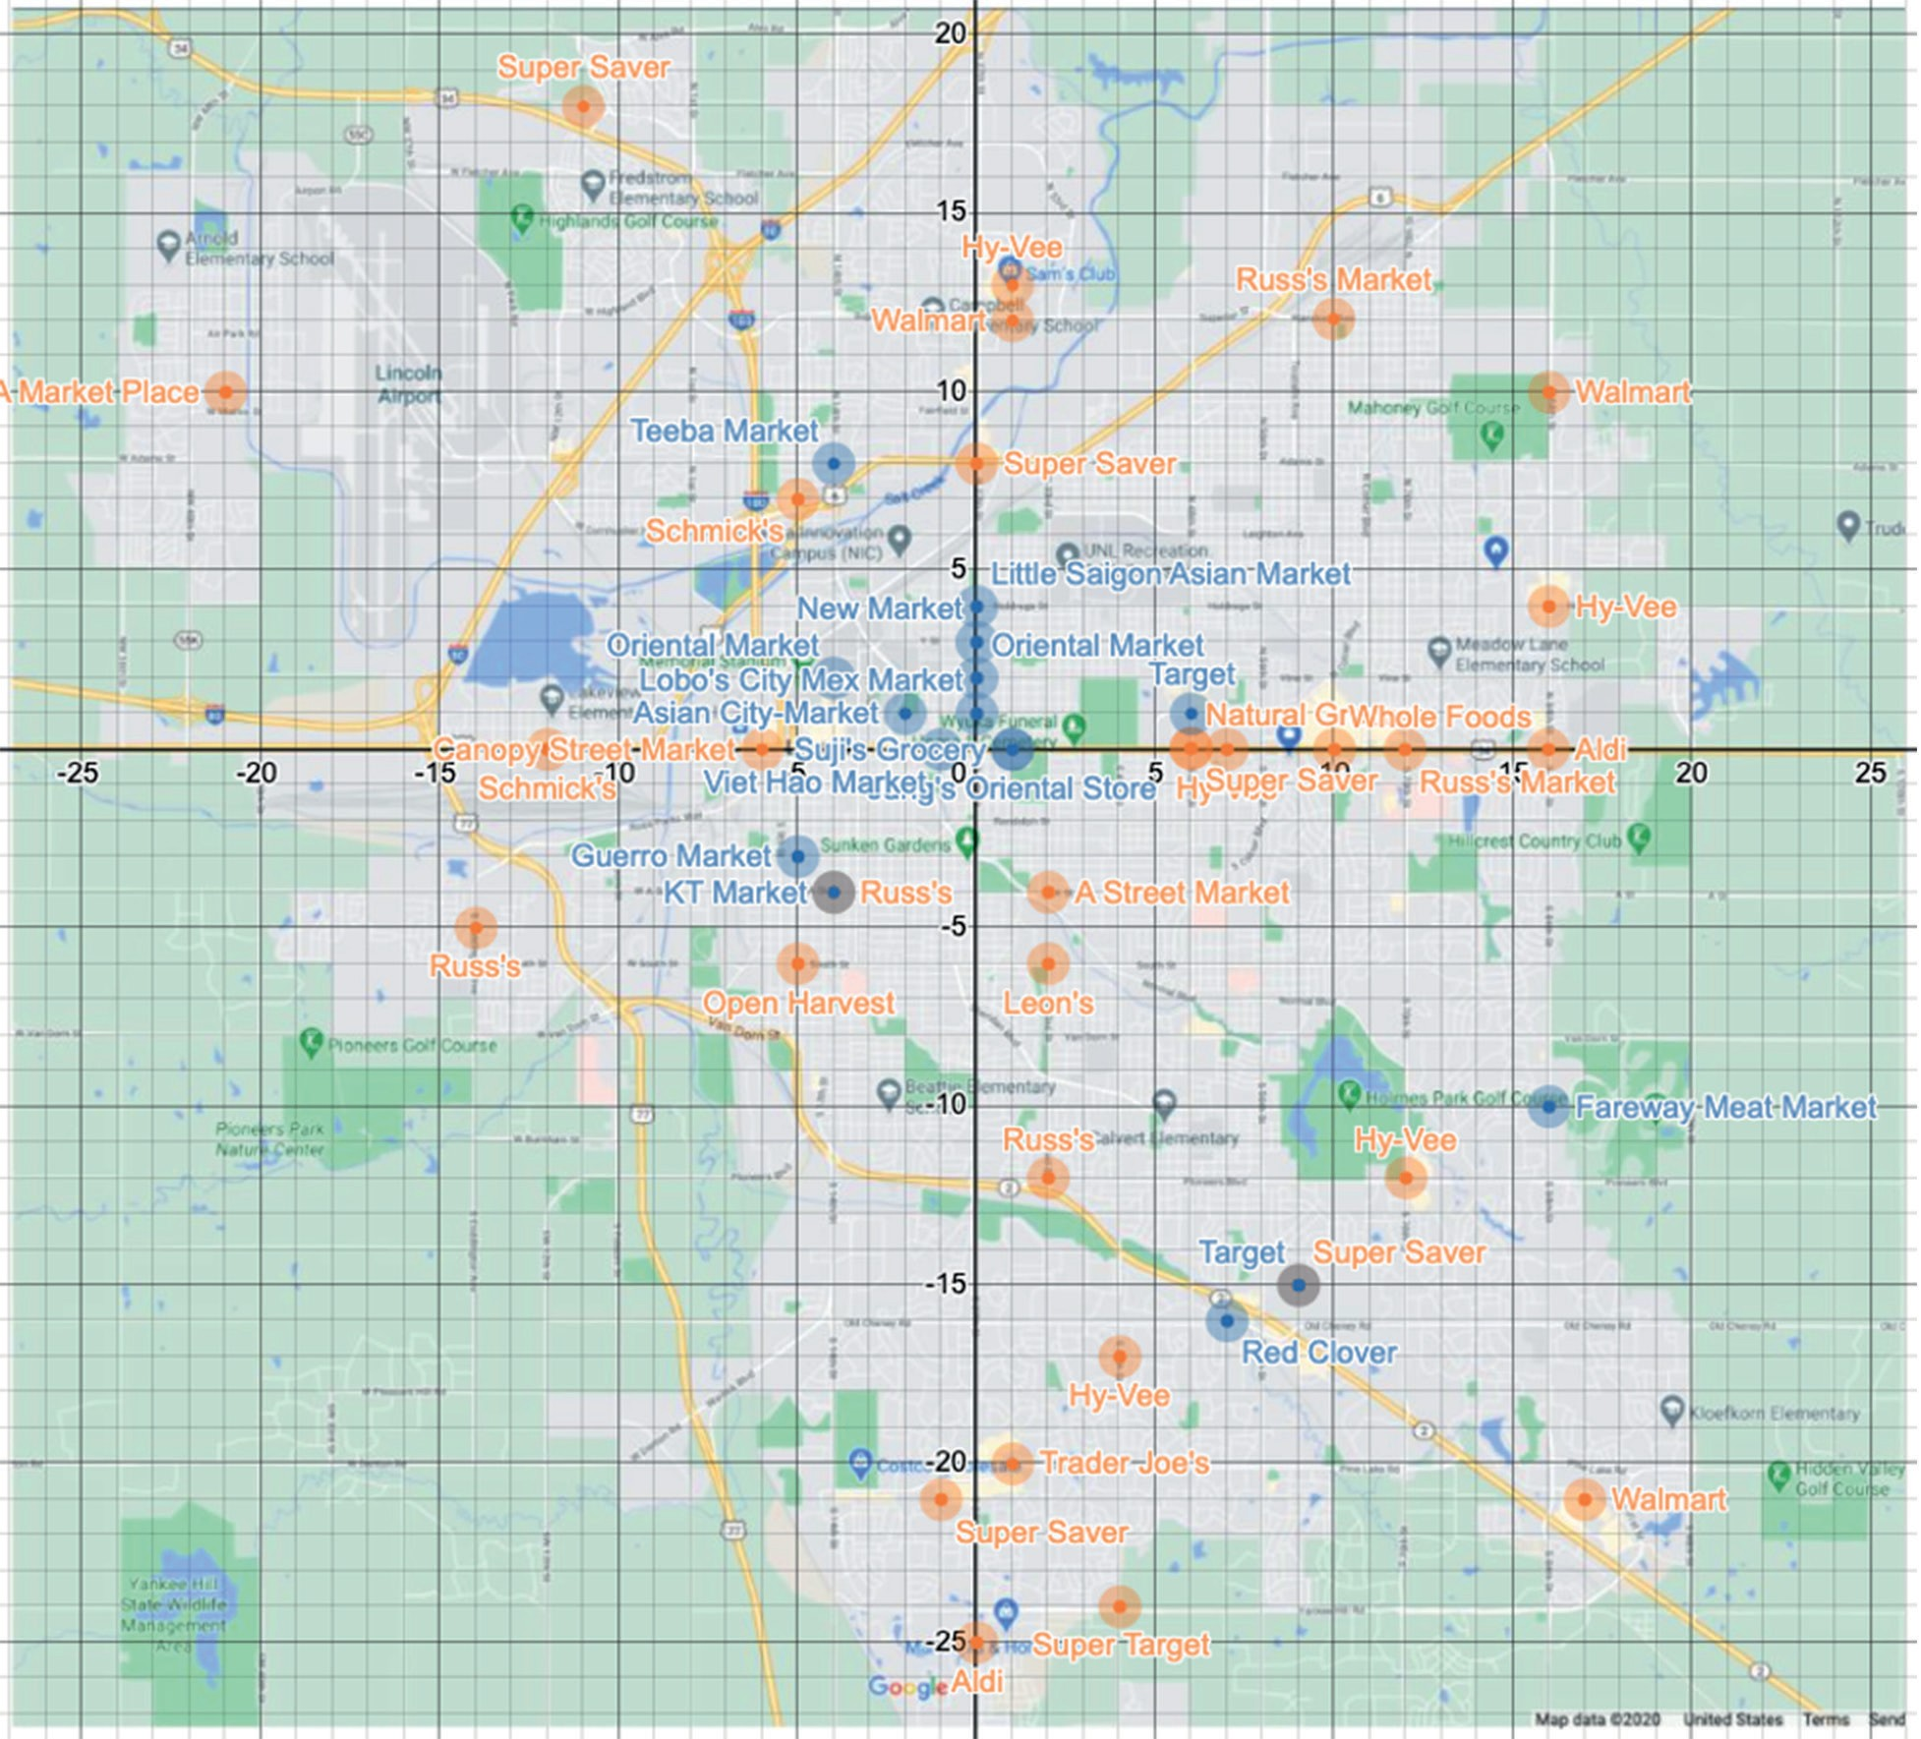
Source: Map data ©2020 Google

Retrieved from the companion website for Middle School Mathematics Lessons to Explore, Understand, and Respond to Social Injustice by Basil M. Conway IV, Lateefah Id-Deen, Mary C. Raygoza, Amanda Ruiz, John W. Staley, Eva Thanheiser, and Brian R. Lawler. Thousand Oaks, CA: Corwin, www.corwin.com. Copyright © 2023 by Corwin Press, Inc. All rights reserved. Reproduction authorized for educational use by educators, local school sites, and/or noncommercial or nonprofit entities that have purchased the book.

