Teacher Resource 2, Sample Family Letter

Sample Family Letter

Families:
Within our classroom, I would like to incorporate different perspectives from our families. I want your first grader to feel like this classroom is an extension of their home. To do this, I need your help. If you have any pictures which show your family’s heritage, culture, native land, or religion, can you share them with me? I will make a copy and send the original back to you. The pictures will be displayed in our class. We will use them to learn about each other, and we will use the pictures during different lessons within our class like writing, storytelling, and math.
Also in math we are developing our counting skills. To do this we need to count a lot of things! To help develop these skills and help students see themselves as mathematicians, we would like them to count things from home. Please send with your child a small collection of items. This could be a small collection of coins, buttons, beads, small toys—any number of items that your child finds necessary to practice counting. Please send them in a bag with the number of items written on it so that we can keep these treasures safe. If you do not have the items to send, please write or call and tell me what items you count at home so that we can include those in our class discussions.
Below you will see some examples of items to count. I want to thank you for allowing me this invitation into your home life, and I want to thank you for joining me to make this classroom an extension of your home.
Much appreciation, Mrs. McCombs
Examples of items to count:

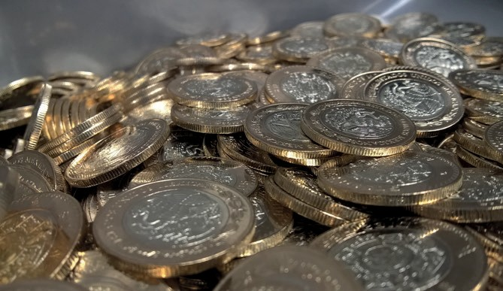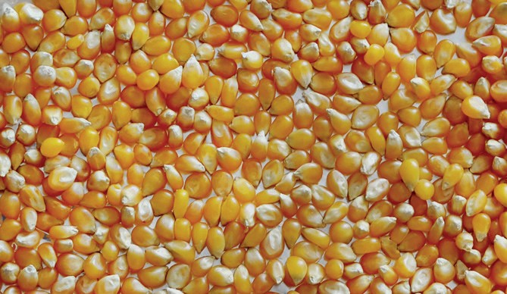

Image Sources: Coins courtesy of pixabay: https://pixabay.com/photos/coins-mexican-peso-money-economy-2879006/; Hair beads courtesy of Shardayyy, “46/365 - 02/15/11 - Hair Beads” licensed under CC BY 2.0 (https://creativecommons
.org/licenses/by/2.0/); Unpopped corn courtesy of pixabay: https://pixabay.com/photos/popcorn-corn-macro-kernel-kernels-76512/.

Retrieved from the companion website for Early Elementary Mathematics Lessons to Explore, Understand, and Respond to Social Injustice by Courtney Koestler, Jennifer Ward, Maria del Rosario Zavala, Tonya Gau Bartell, and colleagues. Series Editor Brian R. Lawler. Thousand Oaks, CA: Corwin, www.corwin.com. Copyright © 2023 by Corwin Press, Inc. All rights reserved. Reproduction authorized for educational use by educators, local school sites, and/or noncommercial or nonprofit entities that have purchased the book.

