Worksheet 6, Gerrymandering Extension Questions

Gerrymandering Extension Questions

In your Inverse Variation Project, you determined the area of 1 through 5 equally divided sections of your country’s area— pretending that it was in the shape of a rectangle. Although the notion of rectangular-shaped countries is not realistic, sec- tioning land for political reasons is a real occurrence. Please feel free to research online to help you answer the questions that follow. All responses should be written in 2 or more complete sentences.
- If you could divide Evanston into 5 to 6 areas with approximately the same number of people living in each area, what would be the best way to do it? Justify.

- Define the term redistricting in your own words.

- Define the term gerrymandering in your own words.

- How do redistricting and gerrymandering work in Evanston?

- Who do you think should decide how legislative districts are drawn? Justify.

- Why did President Obama, among others, want to reform (change) the redistricting process?

- The City of Evanston is divided into wards as shown in the image below (which can also be viewed at https://bit
.ly/2ZUBJ7C).
  - What do you notice?
  - What do you wonder?
  - What factors do you think contribute to how the wards are divided and sectioned in Evanston? Justify.
  - Do you think we as a society should pay more attention to the issue of redistricting? Justify.

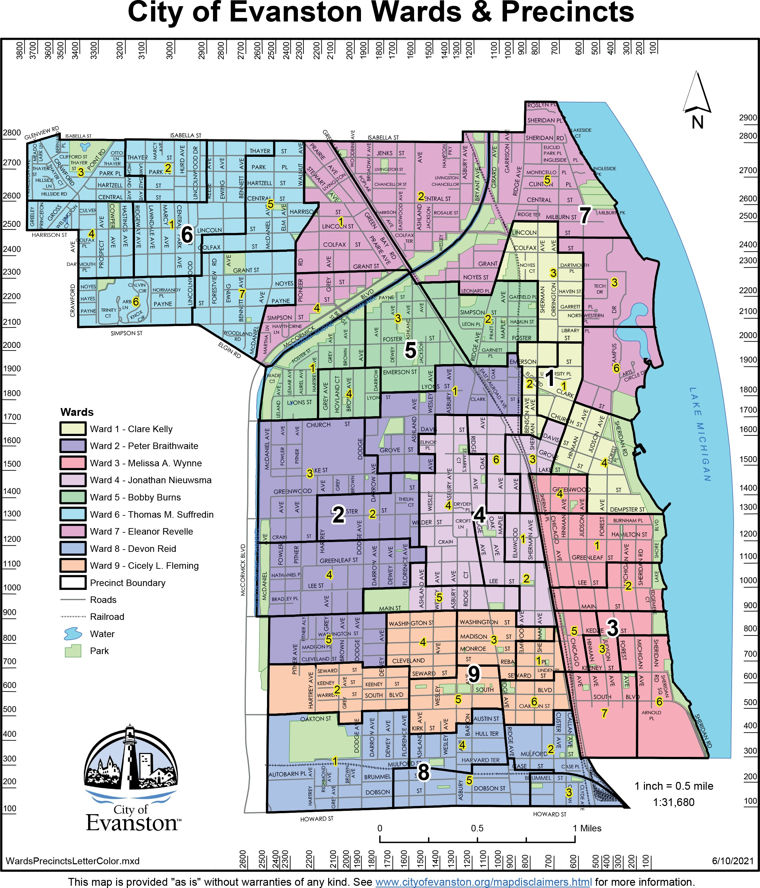

Source: Cityofevanston.org

