Worksheet 2, Math for All Playground

Math for All Playground

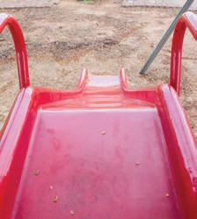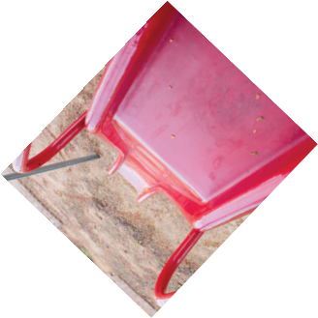Source: climber wall photo by Aksionava/iStock.com; slide photo by bankajk/iStock.com

Climb

r Wall

Ramp

with Rai

ls

Tic T w

ac Toe ith Brail

Panel le
e

Math for All Playground Directions

The scale of this playground is:
Use the given scale factor to determine the following:

Side lengths for horizontal and vertical pieces. Justify your answer. | Total length and width of the playground if it were a rectangle (footprint). Explain how you found the foot- print.
Total area of the playground equipment. Justify your answer. | Estimated dimensions of a rectangular use zone (at least 4 feet longer on all sides of the footprint) and the total area of the use zone.

