Worksheet 1, Research Template

Research Template

for Accessible Playground Items

Example

Object Name:  Single Seat Swing Platform With Frame | Cost:  $1,699.99
Dimensions:  8’ × 8’ | Use Zone:  20’ × 32’
Website: https://www.aaastateofplay.com/swing-platform-with-frame/
Picture / Sketch of Object:  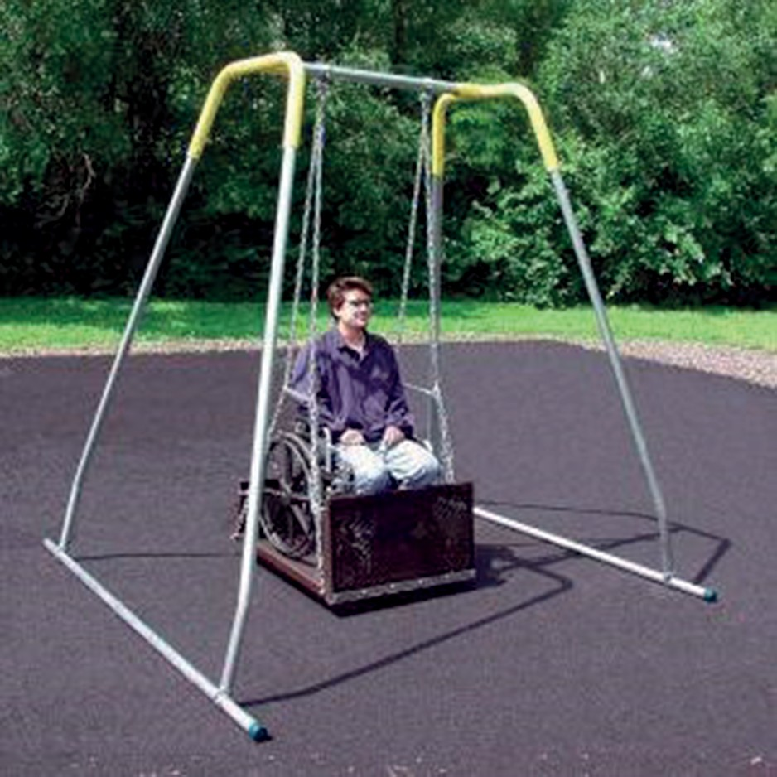  Source: AAA State of Play. | Why I Chose This Object:  I thought it was important to include a swing for larger wheelchairs, where people would have enough space to access the swing and use it properly.

Research Template
for Accessible Playground Items

Object Name: | Cost:
Dimensions: | Use Zone:
Website:
Picture / Sketch of Object: | Why I Chose This Object:

Object Name: | Cost:
Dimensions: | Use Zone:
Website:
Picture / Sketch of Object: | Why I Chose This Object:

