Student Resource 1, Exploring Maps

Exploring Maps

Use for Question 1  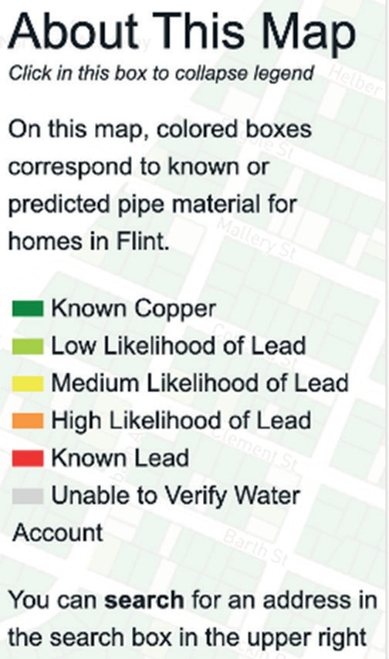 | Use for Question 3  Sentinel site results show gradual improvements in the #FlintWater system. #FlintFWD  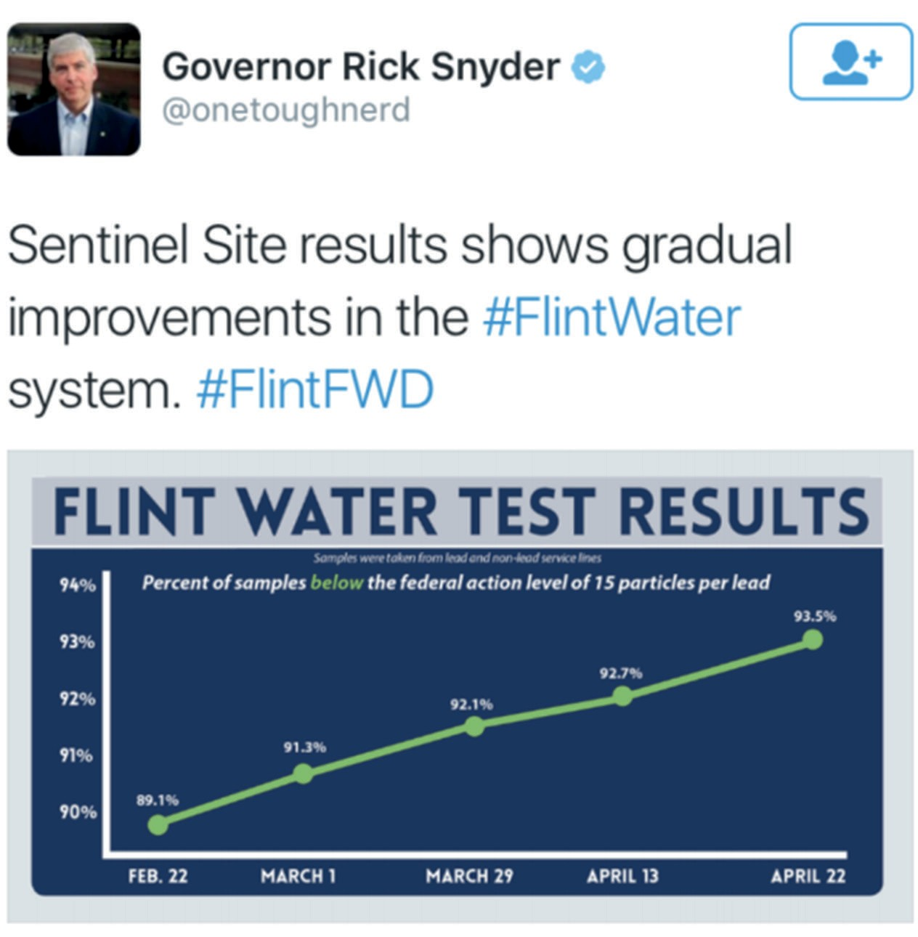  Source: Twitter.com
Use for Question 2

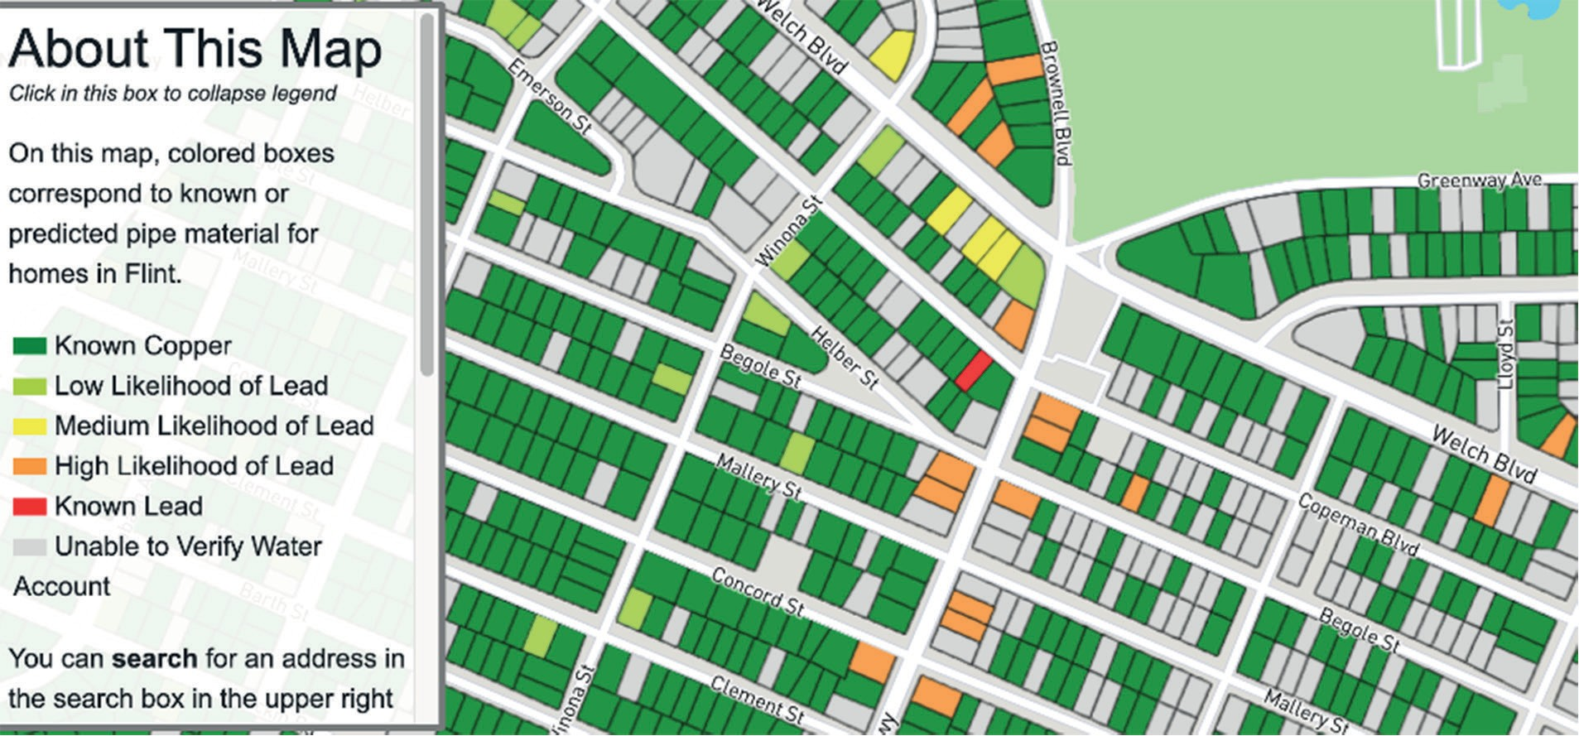
Source: The information on the map has been supplied by the City of Flint and/or based on the results of a mathematical model designed by Dr. Jacob Abernethy, Dr. Eric Schwartz, and Jared Webb in collaboration with the University of Michigan.

Retrieved from the companion website for Middle School Mathematics Lessons to Explore, Understand, and Respond to Social Injustice by Basil M. Conway IV, Lateefah Id-Deen, Mary C. Raygoza, Amanda Ruiz, John W. Staley, Eva Thanheiser, and Brian R. Lawler. Thousand Oaks, CA: Corwin, www.corwin.com. Copyright © 2023 by Corwin Press, Inc. All rights reserved. Reproduction authorized for educational use by educators, local school sites, and/or noncommercial or nonprofit entities that have purchased the book.

