Worksheet 2, Info Sheet

Info Sheet

Measurement Units

Volume
z 1 cubic centimeter (cm3) = 1 milliliter (ml)
z 1 liter (L) = 1,000 ml (same as a 10 cm × 10 cm × 10 cm cube)
z 1 cubic meter (m3) = 1,000 liters (L) (same as a 1 m × 1 m × 1 m cube)
z 1 gallon is about 3.8 liters

Length
z 100 centimeters (cm) = 1 meter (m)
z 1 meter is about 3 feet

Water Needed Per Day
Below is an excerpt from Red Cross and FEMA guide: “Food and Water in an Emergency” (page 7), https://www.redcross
.org/content/dam/redcross/atg/PDF_s/Preparedness___Disaster_Recovery/Disaster_Preparedness/Food_Safety/Food_ and_Water-English.revised_7–09.pdf
A normally active person needs to drink at least two quarts (half gallon [or about 1.9 liters]) of water each day. People in hot environments, children, nursing [parents], and ill people will require even more.
You will also need water for food preparation and hygiene. Store at least one gallon [or 3.8 liters] per person, per day. Consider storing at least a two-week supply of water for each member of your family. If you are unable to store this quantity, store as much as you can.
Water Requirements for Survival (per person)

Type of Need | Water Needed | Comments
Survival (drinking and food) Basic hygiene practices  Basic cooking needs | 2.5–3 liters per day 2–6 liters per day  3–6 liters per day | Depends on climate and individual  Depends on social and cultural norms  Depends on food and social/cultural norms
Total | 7.5–15 liters per day

Table 1: Excerpt from World Health Organization Guide: “How Much Water Is Needed in Emergencies” (page 9.2), https:// cdn.who.int/media/docs/default-source/wash-documents/who-tn-09-how-much-water-is-needed.pdf?sfvrsn=1e876b2a_6

Finding Formulas
To find relevant formulas, Google for things like “volume cone” or “surface area cylinder” and you should get results like what is shown below.

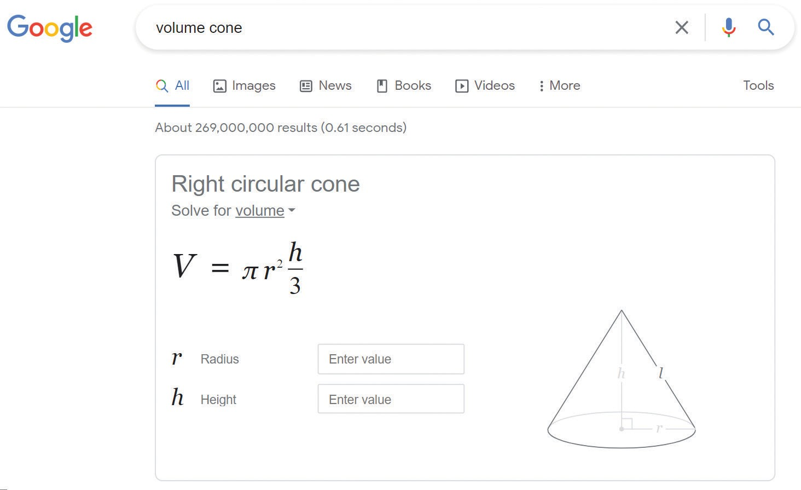

- Notice the drop down arrows where it says “Solve for. . . .” You can change this if needed.
- You will see the formula and the relevant measurements.
- You still need to adjust if part of the shape is not relevant (for instance, where you connect two shapes).

