Visualizing Division Through Sharing Problems (Decimals)
Use your basic facts to reason about how much each sharer will get.
Quantity | Visual Representation | Number of Sharers | Amount for Each Sharer | Related Equation
0.8 | 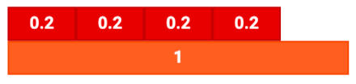 | 4 | 0.2 | 0.8 ÷ 4 = 0.2
1.2 |  | 4
0.9 |  | 3
4.6 |  | 3
3.8 |  | 4

