Visualizing Division Through Sharing Problems (Fractions)
Use your basic facts to reason about how much each sharer will get.
Quantity | Visual Representation | Number of Sharers | Amount for Each Sharer | Related Equation
$$\frac{4}{5}$$ | 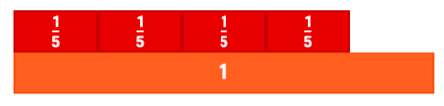 | 4 | $$\frac{1}{5}$$ | $$\frac{4}{5}÷4= \frac{1}{5}$$
$$\frac{6}{9}$$ |  | 3
$$\frac{2}{3}$$ |  | 4
$$\frac{7}{8}$$ |  | 2
$$3\frac{3}{4}$$ |  | 5

