APPLICATION TASK: SCHOOL’S OUT—CLOCK IN—ROCK ON!
School is out for summer! Don’t rejoice too long, because summer fun can come with a price tag. One of your favorite bands is coming to town during the summer and you need to buy your own ticket. The better the seat you want, the more you’ll have to pay. In order to pay for your seat, you have decided to get a summer job.

Orchestra: $280

Backstage Pass: $550
STAGE
MEZZANINE OVERHANG

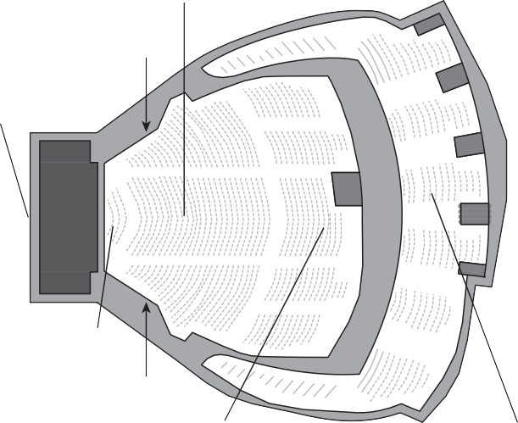
3

2
PIT

16 15
8
14
7
MIX 13
13
6
The prices for different seats are shown on the venue map on the left. These prices are as follows:
Balcony: $150 Mezzanine: $190

Pit: $350
12
1 5
11
4

MEZZANINE 9 10
OVERHANG
Orchestra: $280 Pit: $350
Backstage Pass: $550

Mezzanine: $190 Balcony: $150

You have been looking at local job listings for students on summer break and found the following opportuni- ties for work, including when they start, how much you would get paid for each day you work, and how many days you could work each week.

Job | Start Date | Daily Rate | Days per Week | Weekly Rate
Lifeguard | Week 1 | $45 | 2
Babysitting | Week 3 | $30 | 4
Dog Walking | Week 0 | $15 | 5
Ice Cream Server | Week 2 | $40 | 3
Mowing Lawns | Week 0 | $50 | 1

Each group will be assigned different information to fill in the following question frame for this task:

If the concert is in weeks, and you want to buy the ticket, which two jobs are the best to help you reach your goal? Which job is not a good option?

You will present your group’s work on a collaborative poster. The poster must have four sections, one for each of today’s success criteria. In each section, you will present your work demonstrating mastery on that I can statement. For example, the first I can statement is “I can mathematically model a situation with a system of linear equations.” Under that section in your poster, you will need to show several linear equations: one for each of the summer jobs you are modeling, one for your ticket price, and one for your concert deadline. Each equation should be labeled to identify what each variable represents. A sample layout of this poster can be found below.

[Your Number of Weeks and Ticket Type]
- I can mathematically model a situation with a system of linear equations.  Equation for money made from Job 1 over time Equation for money made from Job 2 over time  . . .  Ticket Price: y = [Dollar Amount] Concert Deadline: x = [Week Number] | - I can solve systems of linear equations using my preferred method (algebraically or graphically).  [Solve algebraically here OR  Solve graphically here.]
- I can use my math as evidence to collaboratively construct a claim about a real-world situation.  Based on our evidence above, we claim that the job and  job are the best to reach our goal. On the other hand, the  job is not a good option to reach our goal. | - I can logically communicate how my mathematical evidence supports my claim to my peers.  Our claim is supported by . Additionally,  .

Retrieved from the companion website for Teaching Mathematics in the Visible Learning Classroom, Grades 6–8 by John Almarode, Douglas Fisher, Joseph Assof, Sara Delano Moore, John Hattie, and Nancy Frey. Thousand Oaks, CA: Corwin, www.corwin.com. Copyright © 2019 by Corwin. All rights reserved. Reproduction authorized only for the local school site or nonprofit organization that has purchased this book.

