Name: __________________________________ Date: _________________

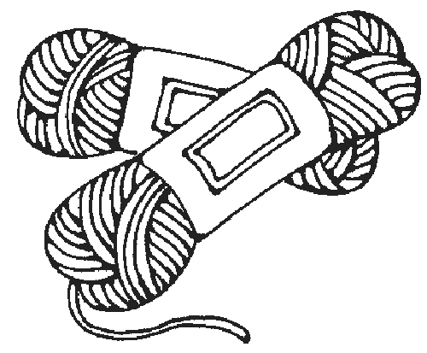
Six inches of yarn are needed to make one bracelet.
Lin has 27 inches of yarn.

How many bracelets can Lin make?

Before she begins, Lim measures again and finds she only has 25 inches of yarn. She knows that this won’t change the number of bracelets she can make. Tell why you agree or disagree with Lin.

