Name: __________________________________ Date: _________________

Read the time. Draw hands on the clock to show 1 hour 30 minutes earlier than the time listed.
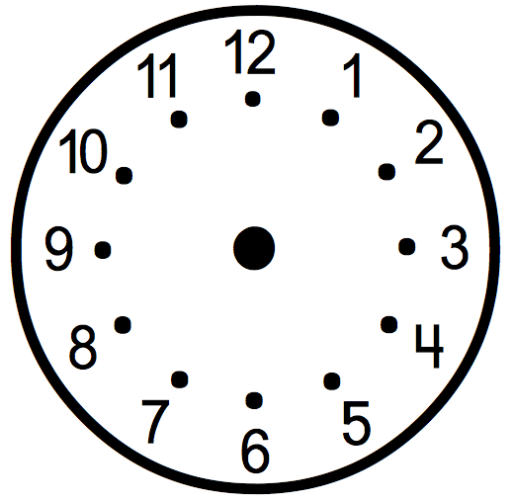
3:30
1:15
7:45

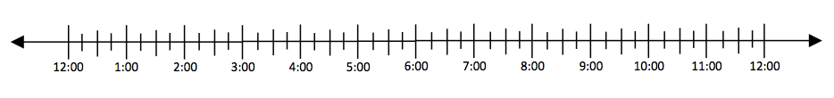

Read the time. Draw hands on the clock to show 3 hours and 15 minutes later.

6:15
4:00
2:30

