Name: __________________________________ Date: _________________

Dave’s practice starts at 5:30 and is 2 ½ hours long. Use the number line to show when Dave’s practice ends.
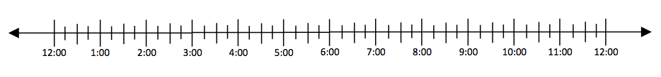

A play is 3 hours and 15 minutes long and begins at 6:30. What time does it end?

Mia leaves for the beach at 12:30. It takes 4 hours and 45 minutes to get there. When will she arrive?

