Name: __________________________________ Date: _________________

Show each amount of money in two different ways.
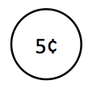
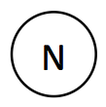
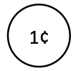
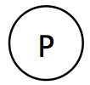
Use or for pennies. Use or for nickels.

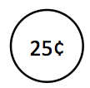
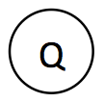
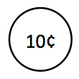
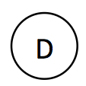
Use or for dimes. Use or for quarters.

87¢

49¢
Big Idea #32: Working and Problem Solving With Money• Task 32B
Retrieved from the companion website for Mine The Gap for Mathematical Understanding: Common Holes and Misconceptions and What to Do About Them, Grades K-2 by John SanGiovanni. Thousand Oaks, CA: Corwin, www.corwin.com. Copyright © 2017 by Corwin. All rights reserved. Reproduction authorized only for the local school site or nonprofit organization that has purchased this book.

