Name: __________________________________ Date: _________________

Derrick had 1,000 blocks. He gave some to Beth. The blocks he has left are below.
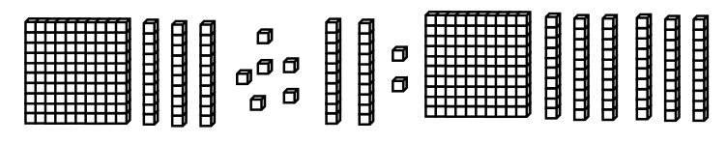

How many blocks did Derrick give to Beth?

