Name: __________________________________ Date: _________________

Write the number that the model shows.
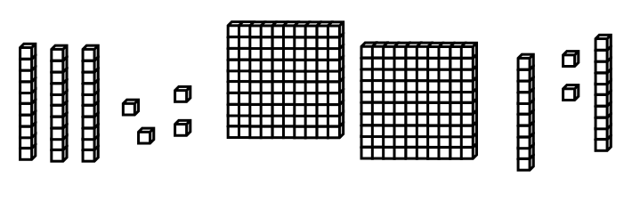

Use and • to create a number GREATER THAN the number above.

Use and • to create a number LESS THAN the number above.

