Name: __________________________________ Date: _________________

Use and • to show the same number that the ten frames show. Then write the number.

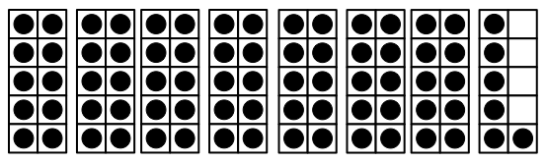

Use and • to show the same number that the ten frames show. Then write the number.

