Name: __________________________________ Date: _________________

Write the number that the model shows.

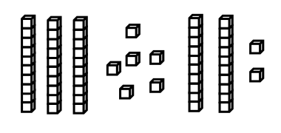

Use sticks and dots • to show the number in two different ways.

