Name: __________________________________ Date: _________________

Draw hands on the clock to show the time written below it.
Then show each time on the number line
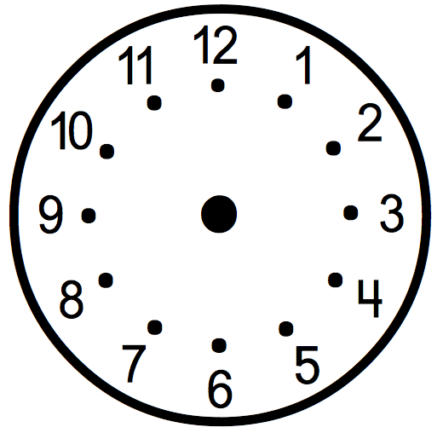
3:30
1:15
7:45

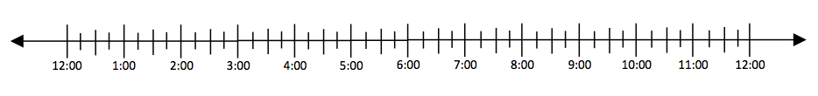

Create a time and write it below the clock and show it on the clock.
Then show each time on the number line below.

