Name: __________________________________ Date: _________________

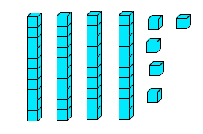
Use the blocks to answer the questions below.

Write the number that is 7 more than the blocks.

________________________

Write the number that is 13 more than the blocks.

______________________

Write the number that is 3 less than the blocks.

________________________

