Name: __________________________________ Date: _________________

Find the missing numbers for each equation.
You can use the number line to help you.

__________ + 3 = 5 11 = 7 + __________

7 + __________ = 9 14 = 7 + __________

5 = __________ + 2 8 + __________ = 12

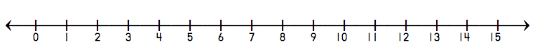

Find the missing numbers for each equation.
You can use the number line to help you.

__________ + 3 = 5 11 = 7 + __________

7 + __________ = 9 14 = 7 + __________

5 = __________ + 2 8 + __________ = 12

