PRODUCTION PROCESS
In production, we work with our authors to fine-tune their books before publication, maintaining your voice and vision while producing a quality product on schedule.
Your production editor (PE) will be your guide through each step of the process, outlined in the following diagram.
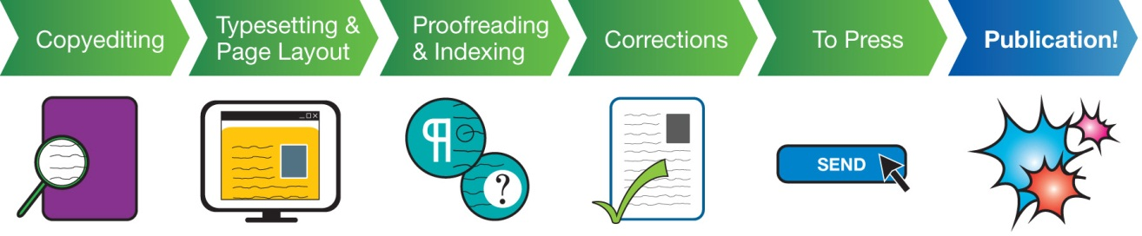
Your involvement will be required in the copyediting, proofreading, and corrections stages. Your PE will keep you apprised of the production schedule so that you know when to expect those steps.

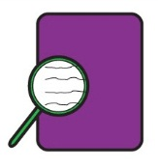
Step 1: Copyediting
Production starts with a careful review of your manuscript. Your PE makes sure that the manuscript is complete and follows up with any questions. Then the PE contracts a copyeditor to edit the text for grammar, style, and consistency. The copyeditor will also double check the citations and references and query for clarity. The copyeditor will send the edited files to you for your review.
We use Microsoft Word’s Tracking feature so that you can clearly see the edits made.
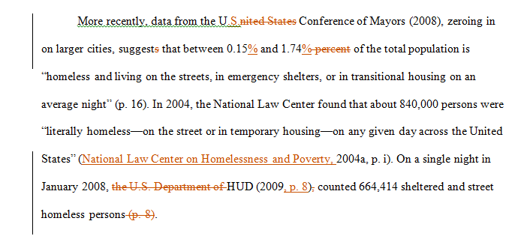
In the below image, the red text represents the copyeditor’s query (providing a callout for a figure) and the blue text represents the author’s edit.
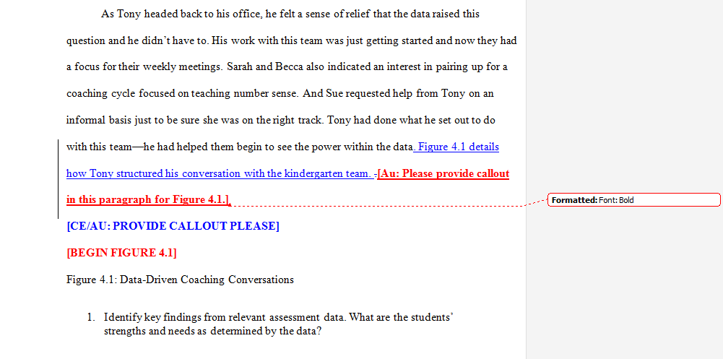
After receiving your edits and responses to the queries, the copyeditor finalizes the edits and returns clean manuscript files to the PE.
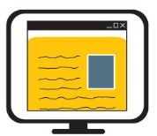
Step 2: Typesetting and Page Layout
The PE reviews the files once more before sending them to typesetting. This is the process in which the text is designed and displayed in pages, just as it will appear when published. The text takes on new life!
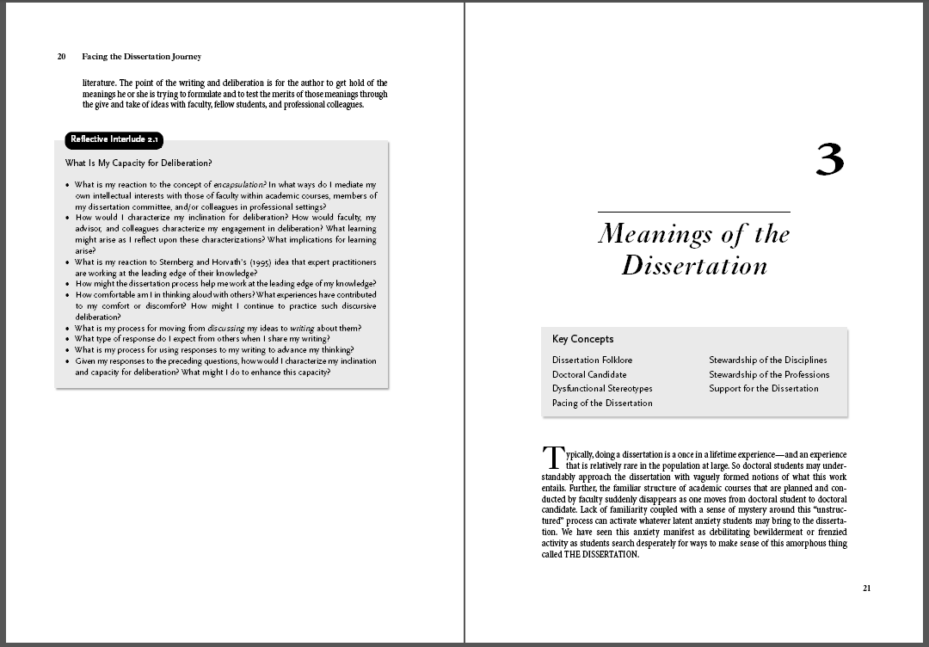

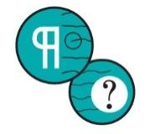
Step 3: Proofreading and Indexing
The PE sends the page proofs provided by the typesetter to you, to a professional proofreader who will carefully read through the pages, and to an indexer who will create an index for the book. If you wish, you may send your PE minor edits, but please note that a thorough review isn’t required, as only the most critical corrections can be made at this stage.
See Electronically Marking Proof Corrections for instructions on reviewing your proofs; your PE will be happy to answer any questions or concerns about this process.
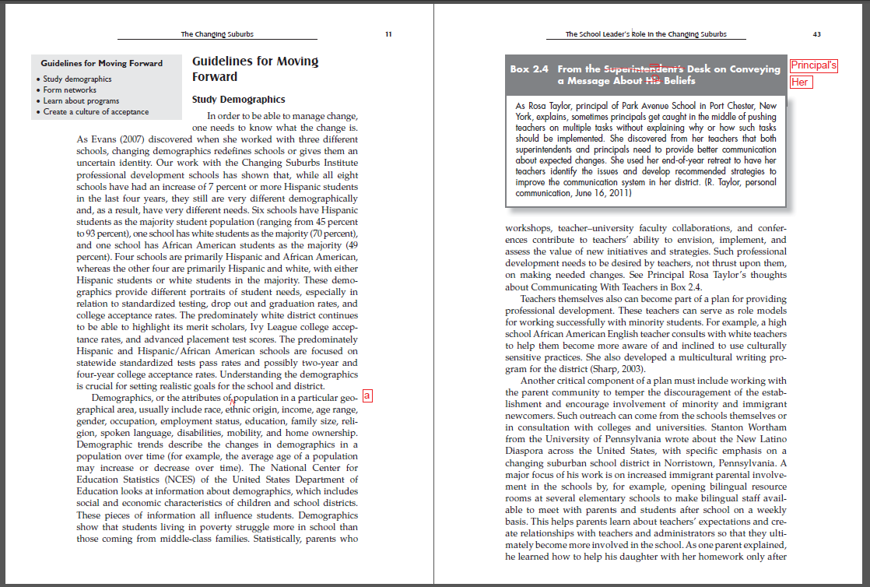
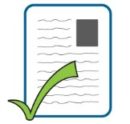
Step 4: Corrections
The PE reviews all the corrections and sends them to our typesetter, who provides revised pages. The PE will send you the new page proofs, including the completed index, for approval before the PE finalizes everything for printing.
Step 5: To Press
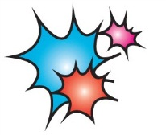
The PE sends the final pages to our printer. The cover artist, who has been designing the cover during this process, also sends the cover file to press.
Step 6: Publication!
Within three to four weeks, your published book arrives in our warehouse. Now it’s time to celebrate and start fulfilling orders!
PRODUCTION TIPS
References
Follow the Publication Manual of the American Psychological Association for references and citations. If you have any questions about style, punctuation, or grammar, please consult The Chicago Manual of Style. Remember that your copyeditor will also be double checking and adjusting the formatting/style as necessary.
Photo Quality
Photos, graphics, and other images must be provided as high-resolution art files. An image may look fine on screen, but in print, it may appear blurry.
It’s fine to embed graphics in the Word files for placement purposes, but because Word tends to reduce the art quality, we request that you also provide separate high-resolution art files.
- A good indicator of the photo quality is the file size. A high-res art file will usually be about 1 to 2 MB.
- JPEG, GIF, and TIFF files are all acceptable.
- Check your photo’s quality by setting your folder View to Details. Right click on the column heads (Name, Date modified, Type, Size) and select “More.” You’ll see a screen where you can pick “Dimensions” (which lists the width and length of the photos in pixels) as a field.
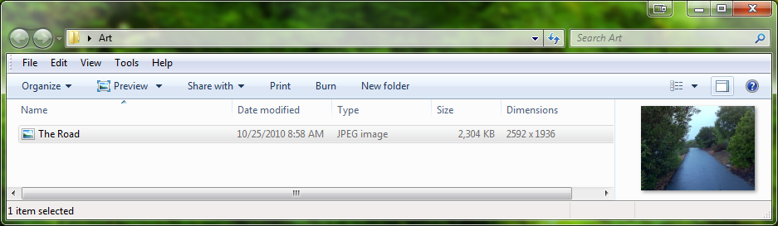
  - If you divide the width and length of your image, listed under the Dimensions heading, by 300, you’ll get a sense of how large the photo can print without losing quality. In the sample photo above, the dimensions are 2592 x 1936, which means that it can be set as large as 8 x 6 inches (2592/300 x 1936/300).
  - A small photo might be 300 x 300 pixels. To preserve the quality, we could size it at 1 x 1 inches. We can set it larger, but the quality will further reduce and the image may look pixelated or grainy.
- Your editorial team and production editor will be in touch if they have any concerns about the photos.
Clipart and Illustrations
Corwin books typically don’t include clipart, and Corwin does not commission illustrations. Please talk to your editorial team if you’d like to include either.
Permissions
Please resolve your permission issues as early as possible. If permissions aren’t received by the time typesetting is scheduled to begin, the book is put on hold while we determine how to move forward.
Indexing
Our indexers are professionals and produce excellent work, but as the content expert, you may wish to provide a list of key terms as a guide, and the indexer will be happy to include them in the completed index.
Text Elements
In your manuscript, set any boxed text elements, tables, or sidebars apart using instructions in different colors. Please do not use text boxes or tabbing.
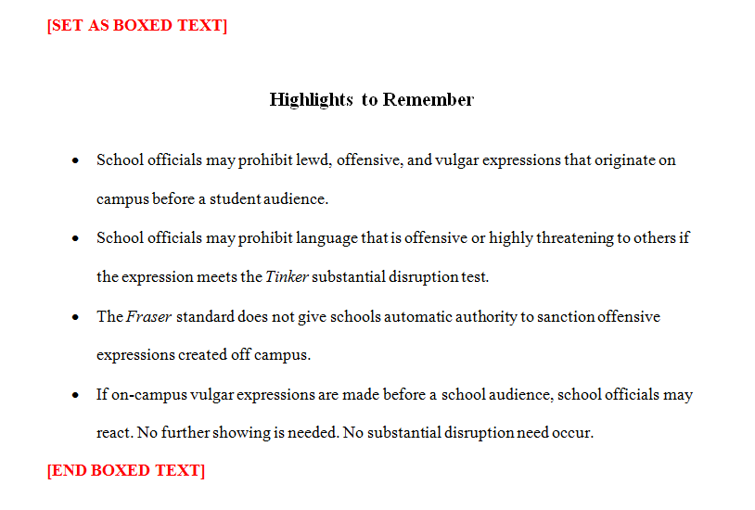

Use similar callouts to indicate where figures should appear.
