How to Assess the Resolution of an Image

Your Corwin editorial team can help you determine whether or not the resolution of your image files is high enough for print publication. However, if you wish, you may assess the resolution of your images.
A good indicator of the photo quality is the file size. A high-res art file will usually be about 1 to 2 MB.
JPEG, GIF, and TIFF files are all acceptable.

Find the dimensions of an image by following these steps:

For PC:
- Open the folder that holds the image.
- Click on the list icon in the top right corner and select Details.
- The Dimensions will appear in the bar below.

-OR-
- Open the photo.
- Open the File menu and select Properties.
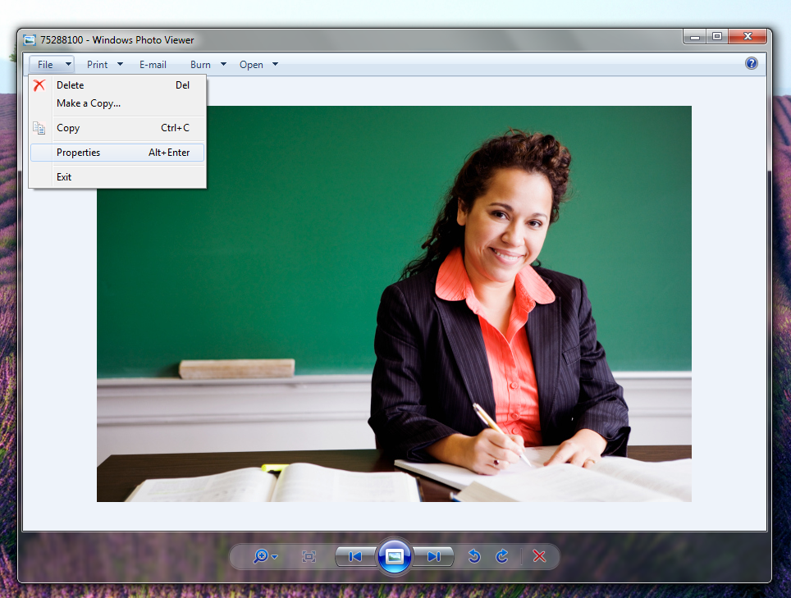
- Under “Image,” you should see the photo’s Dimensions.

For Mac:
- Right-click on the image and select “Get Info.”
- In the box that appears, click on the drop-down menu for “More Info.”
- The Dimensions will be at the top of the list.
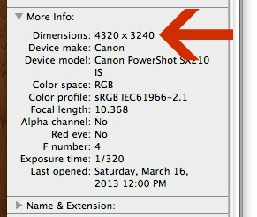
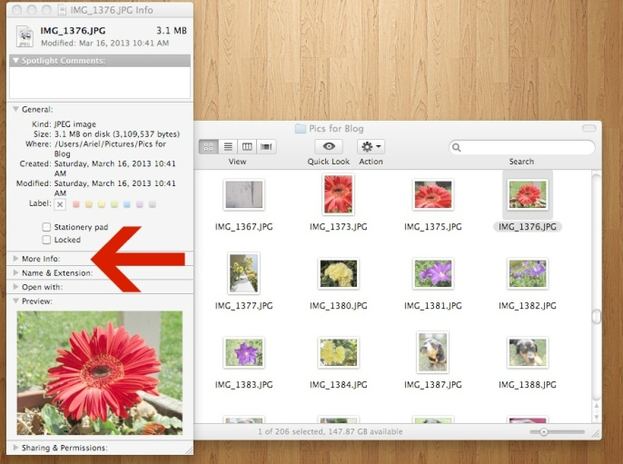

After you find the dimensions of your image, follow these steps to determine whether or not the resolution is high enough for print publication.
1. Divide the dimensions by 300.
2. The resulting numbers show the size, in inches, at which your image can be printed effectively.

Example 1:
Let’s say the image dimensions are 1200 x 1800. 1200 divided by 300 = 4 inches by
1800 divided by 300 = 6 inches. This image can be effectively printed at a size of 4 x 6 inches or smaller. Most photos in Corwin books aren’t any larger than this, so this might be fine. However, if the image is a scan of student work that you were hoping to show at a size of 6 x 8 inches, the image will not print effectively.

Example 2:
Let’s say the image dimensions are 400 x 600. 400 divided by 300 = 1.3 inches by
600 divided by 300 = 2 inches. This image can be effectively printed at a size of 1.3 x 2 inches. This is fine for an author photo. However, it would not work for a classroom scene.

If you have any questions about your image files, please contact your editorial team as early in the process as possible. Early evaluation of your images during the manuscript development process will help ensure that production of your book proceeds smoothly and on schedule.

