Ms. Hensley’s algebra class is working on modeling with mathematics and creating equations to describe numbers and patterns. She has assigned her students the Best Buy Tickets problem to work on individually. As Ms. Hensley circulates through the room, she looks at the students’ work and asks them to explain the process they are using. When Ms. Hensley finishes circulating through the room, she decides to have two volunteers share their methods with the class, though she does not know who she will choose yet. During this process, students in the class can ask the student who is presenting any questions they may have. Ms. Hensley is hoping to promote effective discourse throughout the presentations. The following are examples of some of the work Ms. Hensley observed and can choose from to present.

Sara’s Work
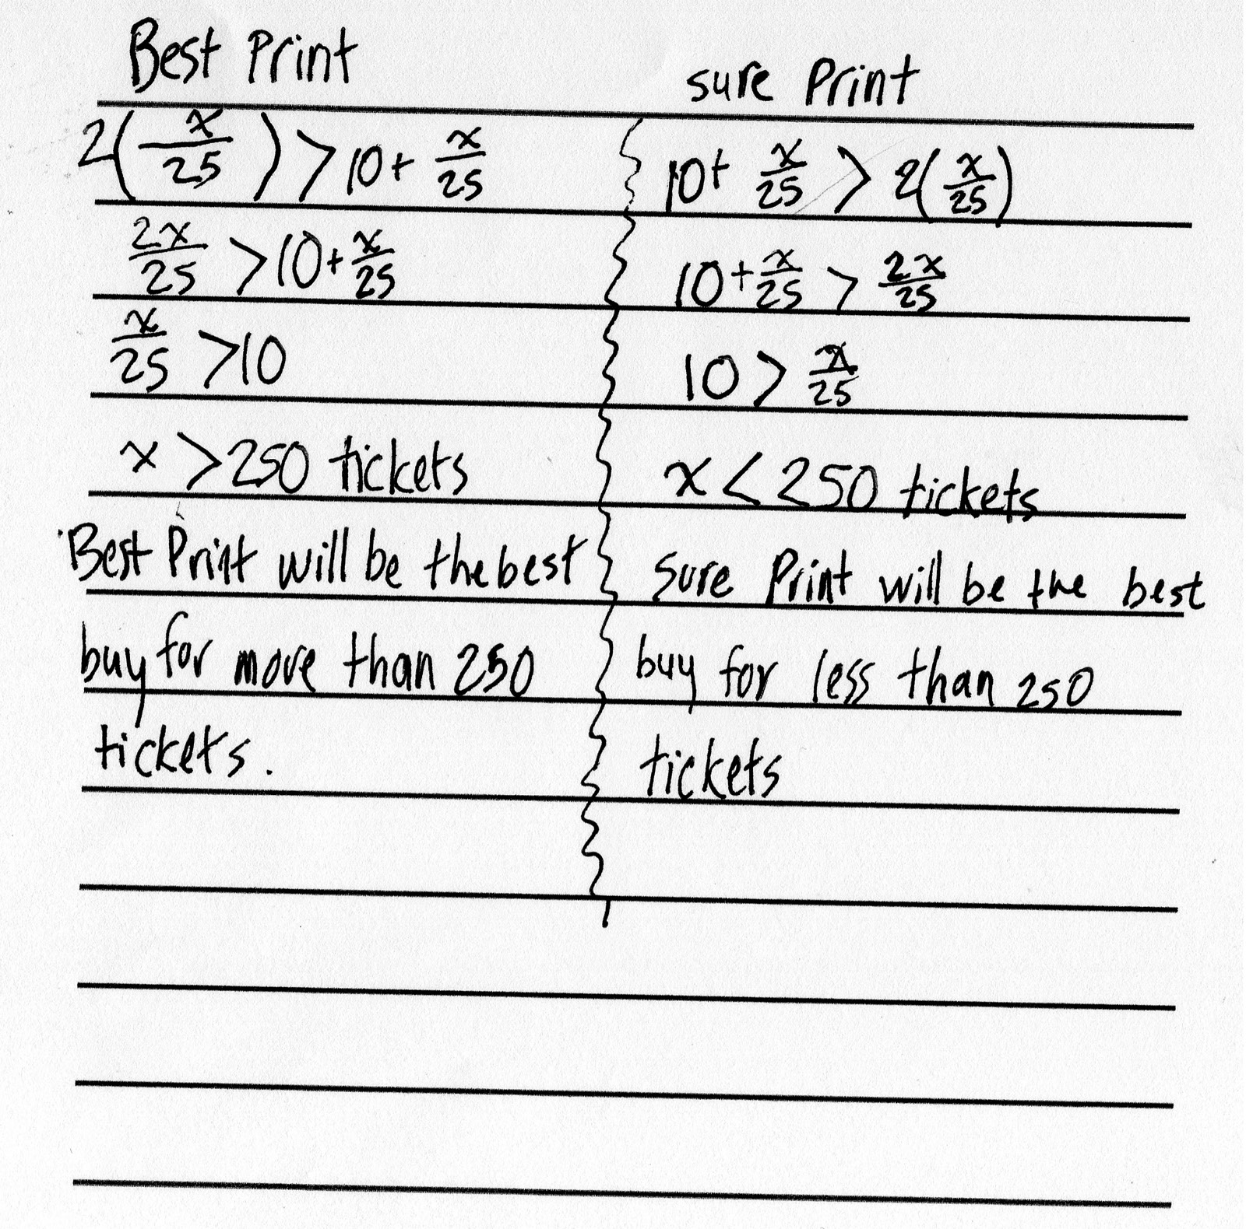

Retrieved from the companion website for Everything You Need for Mathematics Coaching: Tools, Plans, and A Process That Works: Grades K–12 by Maggie B. McGatha and Jennifer M. Bay-Williams with Beth McCord Kobett and Jonathan A. Wray. Thousand Oaks, CA: Corwin, www.corwin.com. Copyright © 2018 by Corwin. All rights reserved. Reproduction authorized only for the local school site or nonprofit organization that has purchased this book.

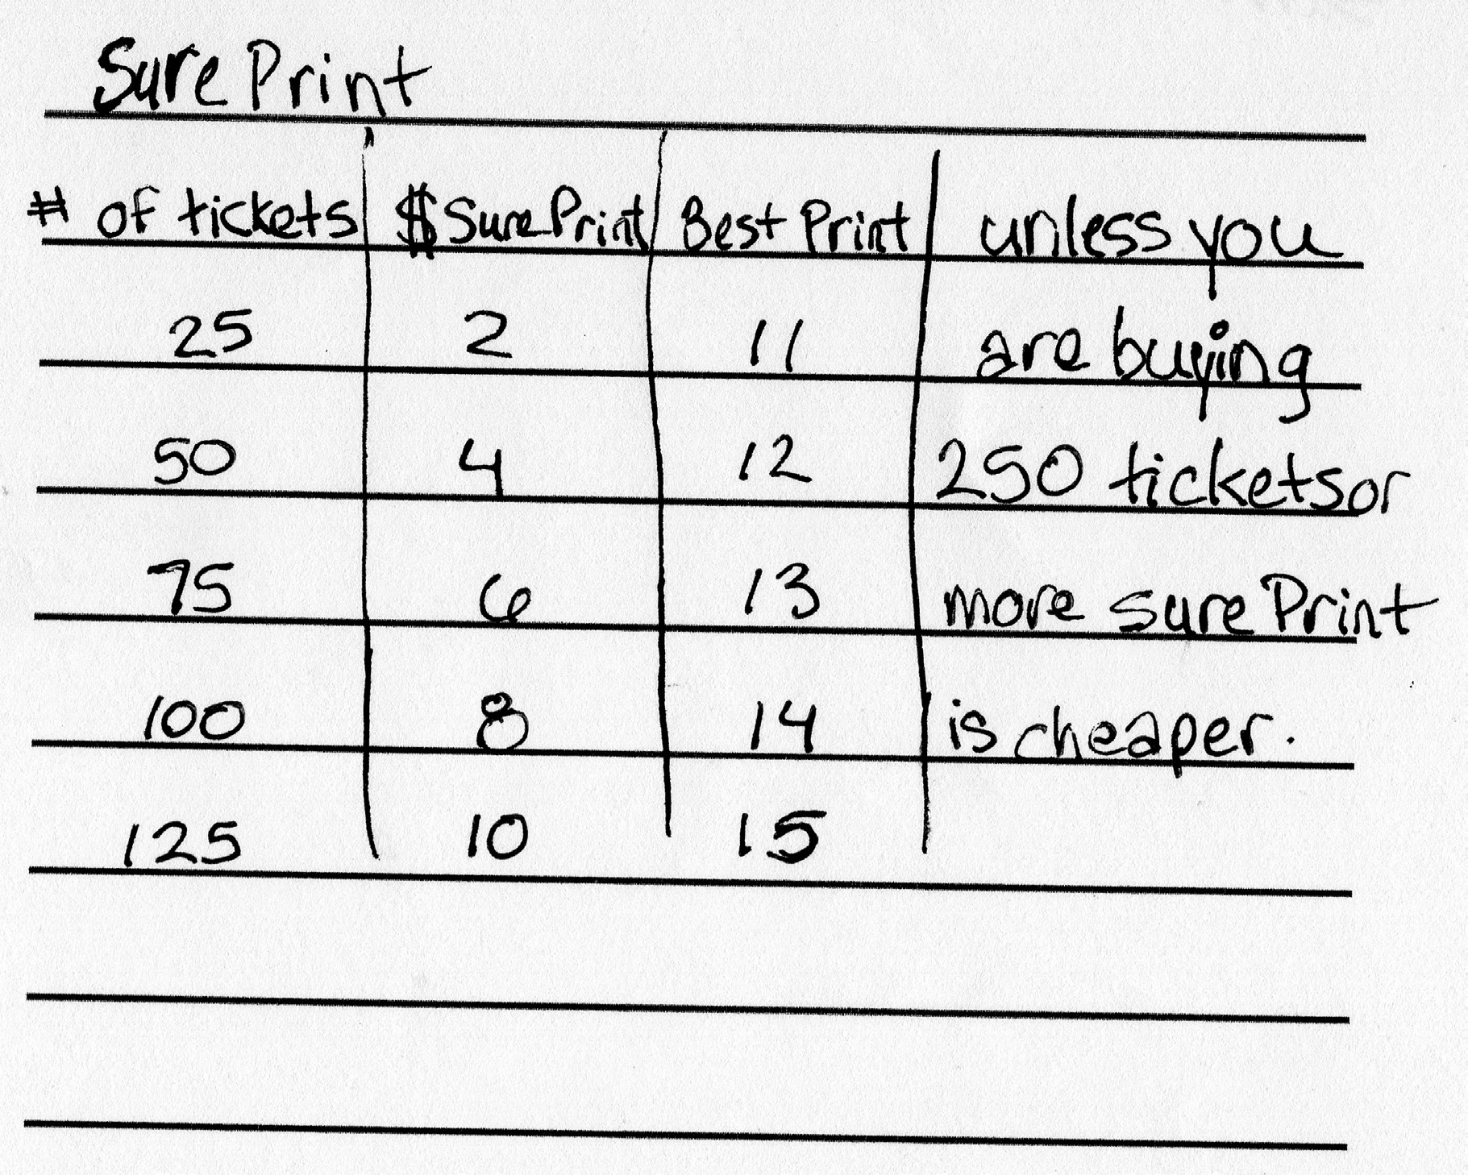
Lena’s Work

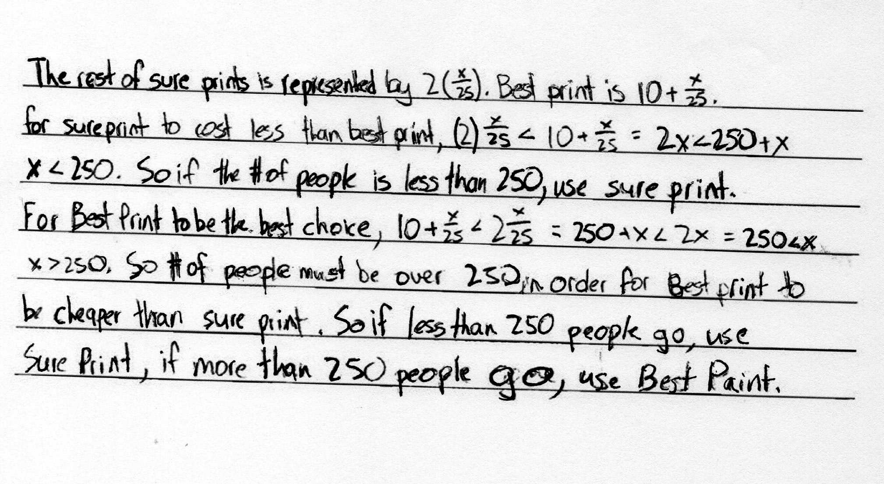
Timothy’s Work

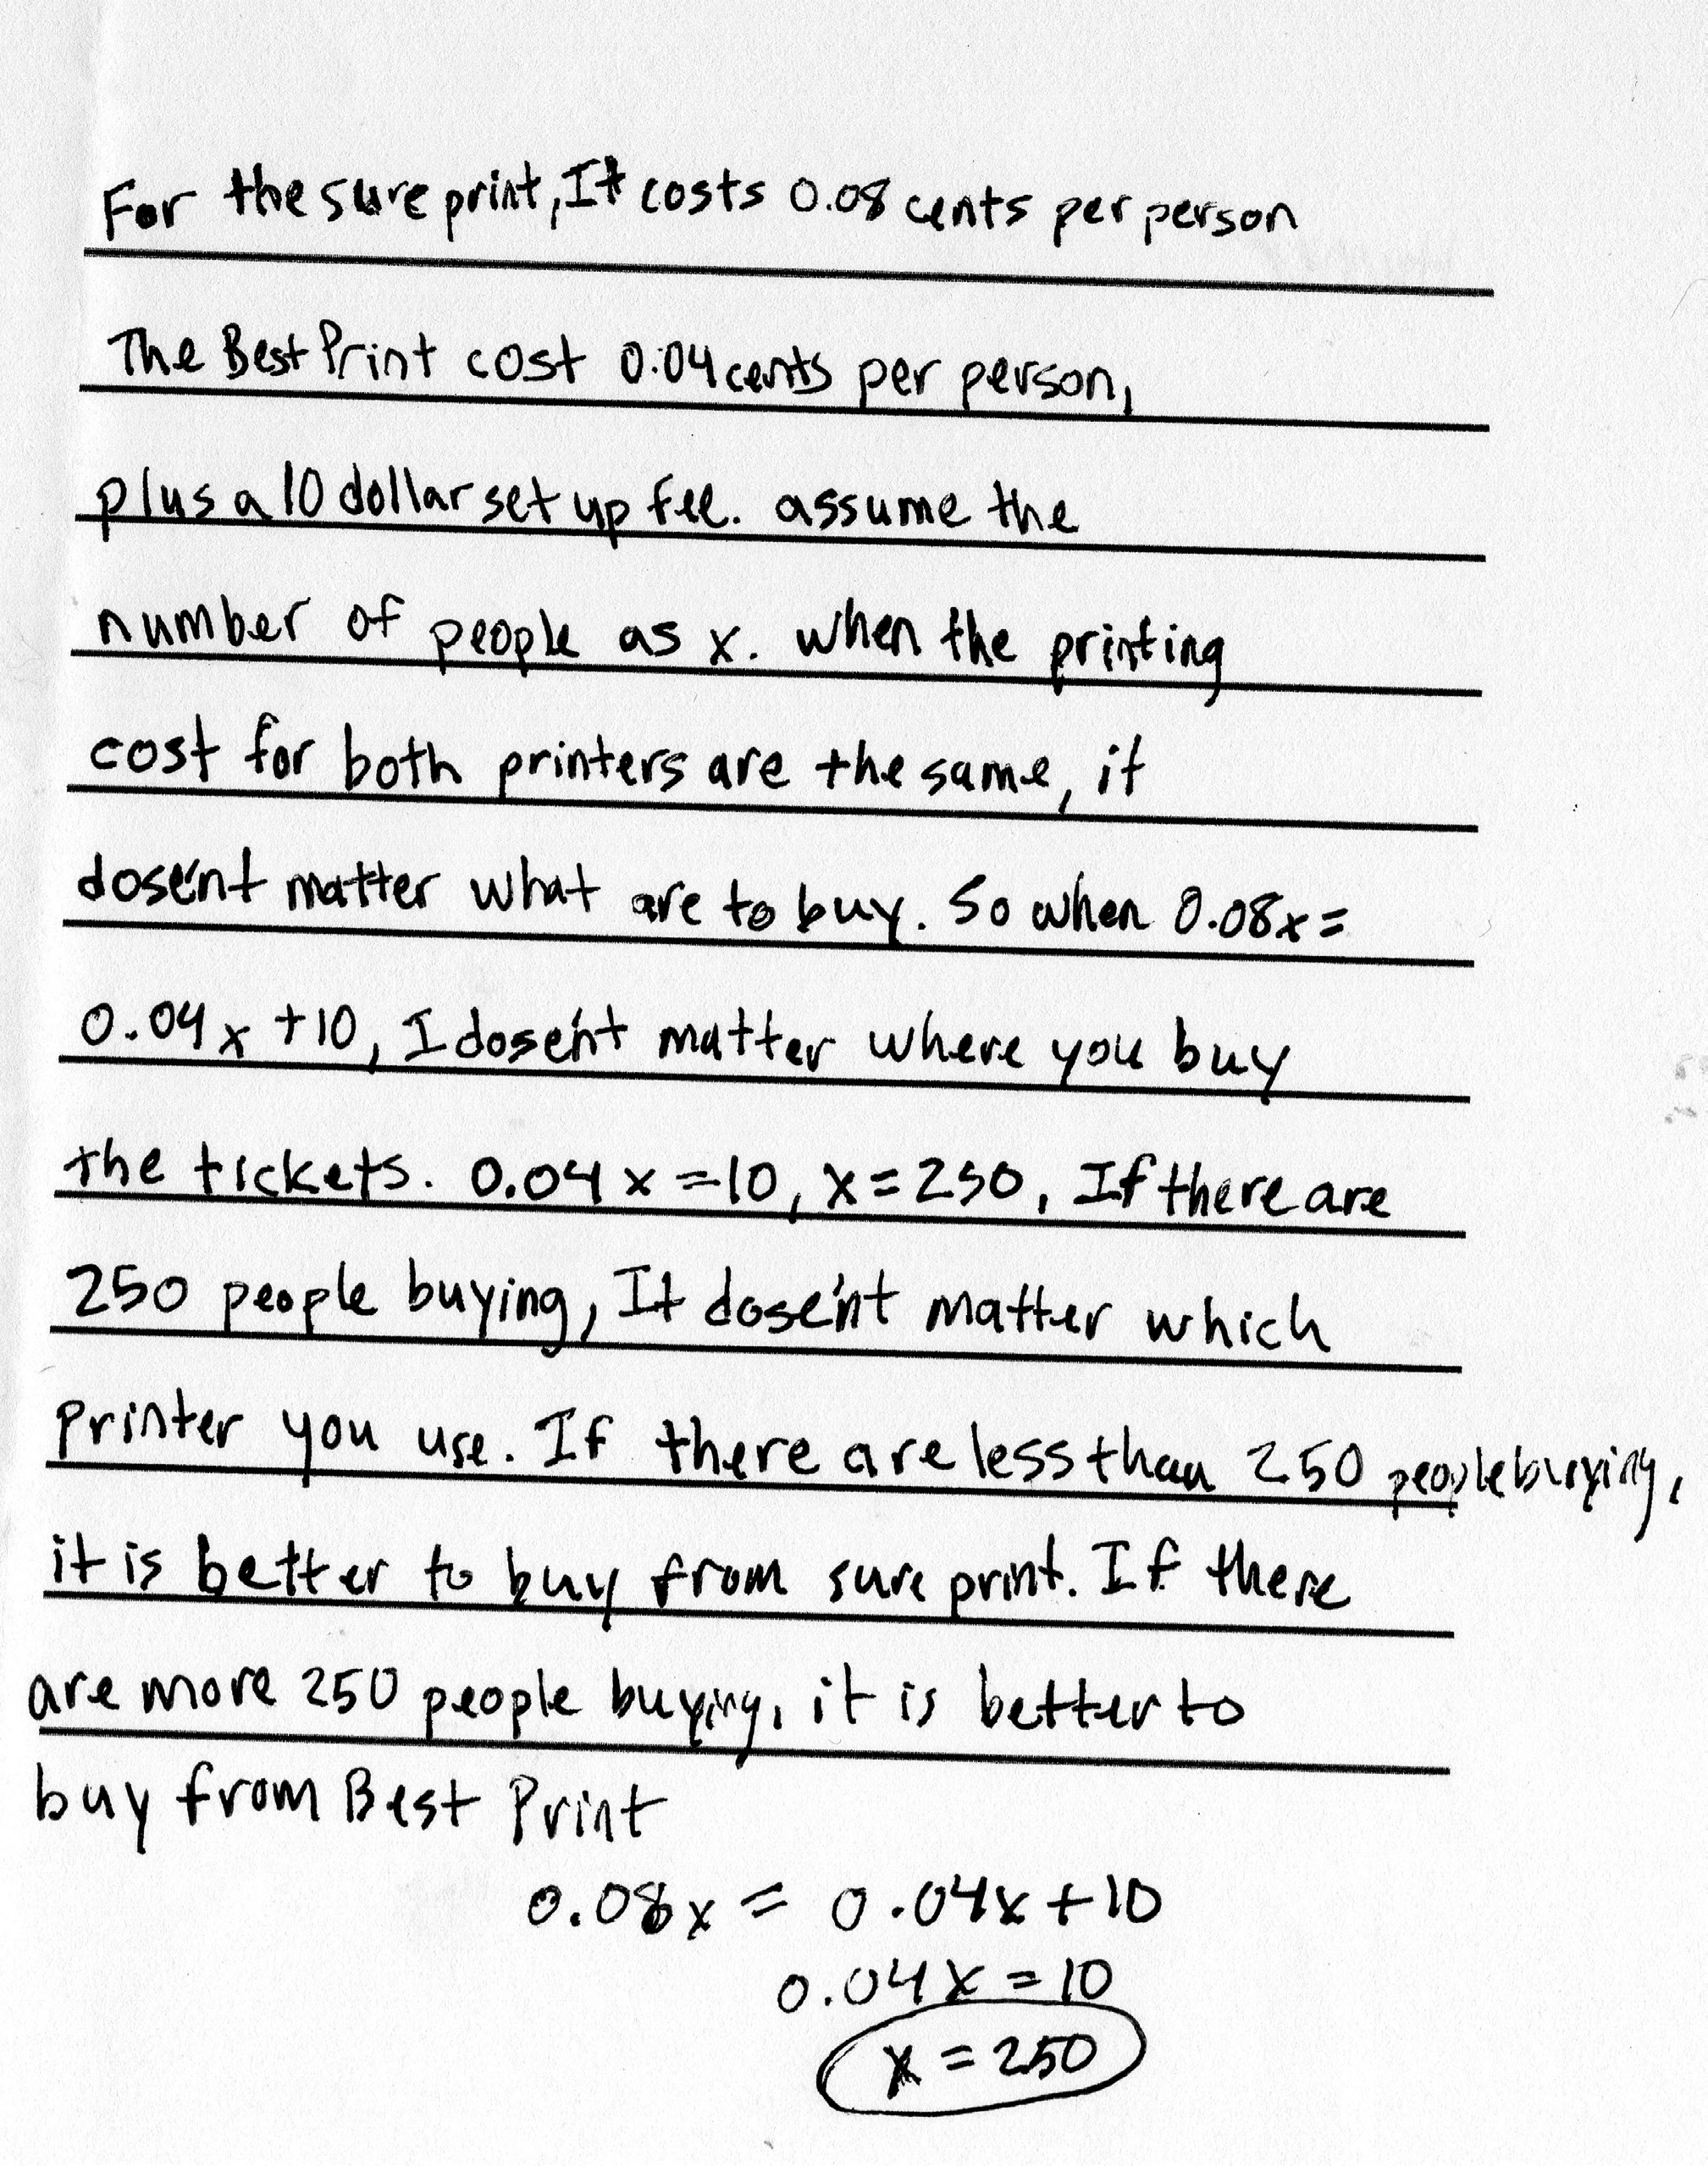
Homer’s Work

In using this vignette with preservice teachers (PSTs), teacher educators found that PSTs often generalized about the best way to present the content in the problem rather than critically responding about the problem itself and the accompanying student thinking and work.

