Planning: Observations Template

Mathematics Standard:
Lesson Objective:
 |  | 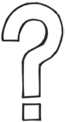 | 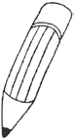
What would you expect to observe? | How would you know “it” if you saw it? | What mathematical challenges or misconceptions might you observe? | How might you record and provide feedback of what you observe?
Images: Clipart.com

Retrieved from the companion website for The Formative 5: Everyday Assessment Techniques for Every Math Classroom by Francis (Skip) Fennell, Beth McCord Kobett, and Jonathan A. Wray. Thousand Oaks, CA: Corwin, www.corwin.com. Copyright © 2017 by Corwin. All rights reserved. Reproduction authorized only for the local school site or nonprofit organization that has purchased this book.

