Name: __________________________________ Date: _________________

Kim showed the commutative property on a number line.

Which multiplication facts does she show?

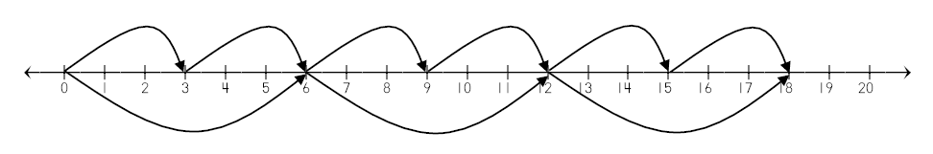

Create two other examples of the commutative property with different multiplication facts. Show them on the number line.

