Name: __________________________________ Date: _________________

A worker is checking to see how many boxes are needed. She knows a machine packs 420 candy bars. It puts 6 candy bars in a box.
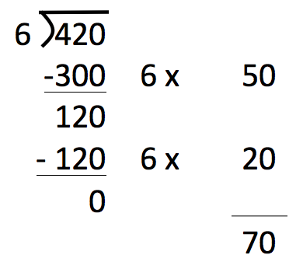
She thinks 70 boxes are needed.
The picture shows how she found her answer.

Explain what she did.

Another machine packs 420 granola bars. It backs 5 granola bars in a box. How many boxes will it need?

Use the worker’s strategy to find how many boxes are needed for granola bars.

