Figure 8.20 Polynomial Concept Attainment

What Is A Polynomial?

These ARE Polynomials | These ARE NOT Polynomials
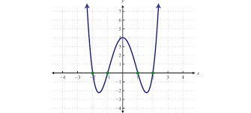  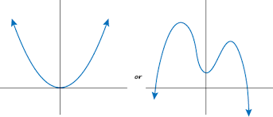  x y x y  –2 –7 –2 2  –1 0 –1 –1  0 1 0 –2  1 2 1 –1  2 9 2 2  $$y=x^{4}+2x^{3}-3x^{2}-5x+7.3$$  $y=2.7x^{5}$  $y=5$ $y=\frac{-3}{4}x^{31}+3x-1$ | 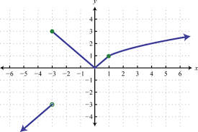  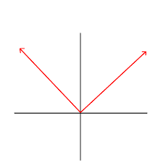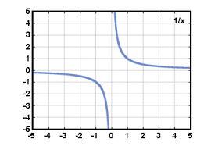  x y x y  –2 –5/2 –1 und.  –1 –2 0 0  0 und. 1 1  1 2 4 2  2 5/2 9 3  $$y=x^{2}+x^{2/3}+3$$  $$y=\frac{x^{3}+2x^{2}-x+1}{x-2}$$  $y=\sqrt{x}$ $y=\sqrt[3]{x}+4$  $$y^{2}=x$$

Write 3 sentences that describe what makes a polynomial, a polynomial.

