Retrieved from the companion website for Every Math Learner, Grades K-5: A Doable Approach to Teaching With Learning Differences in Mind by Nanci N. Smith. Thousand Oaks, CA: Corwin, www.corwin.com. Copyright © 2018 by Corwin. All rights reserved. Reproduction authorized only for the local school site or nonprofit organization that has purchased this book.

Name:

37

ones = 1 ten 20 ones = tens

What is the value of 3 in 34? What is the value of 9 in 59?

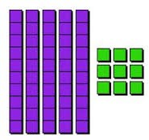
Write 68 in expanded form (notation)

45
What is 1 more? What is 1 less?

What is 10 more? What is 10 less?

