Name:
Retrieved from the companion website for Every Math Learner, Grades K-5: A Doable Approach to Teaching With Learning Differences in Mind by Nanci N. Smith. Thousand Oaks, CA: Corwin, www.corwin.com. Copyright © 2018 by Corwin. All rights reserved. Reproduction authorized only for the local school site or nonprofit organization that has purchased this book.

37

ones = 1 ten 20 ones = tens
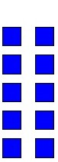

What is the value of 9 in 59? What is the value of 3 in 34?
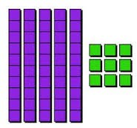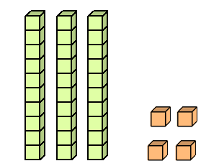

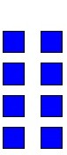
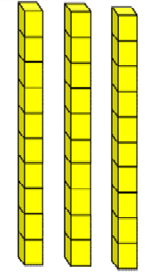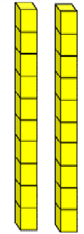Write 68 in expanded form (notation)

45
What is 1 more (+1)? What is 1 less (-1)?

What is 10 more (+10)? What is 10 less (-10)?

