My Math Today

Today I worked hard on ____________________________

__________________________________________________.

I am really good at _______________________________

__________________________________________________.

I need more practice on ___________________________

__________________________________________________.

I am proud of myself because ______________________

__________________________________________________.

I used my time well | 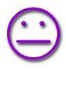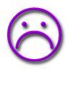
I helped my classmates
I gave my best effort

