STEAM Resource Inventory

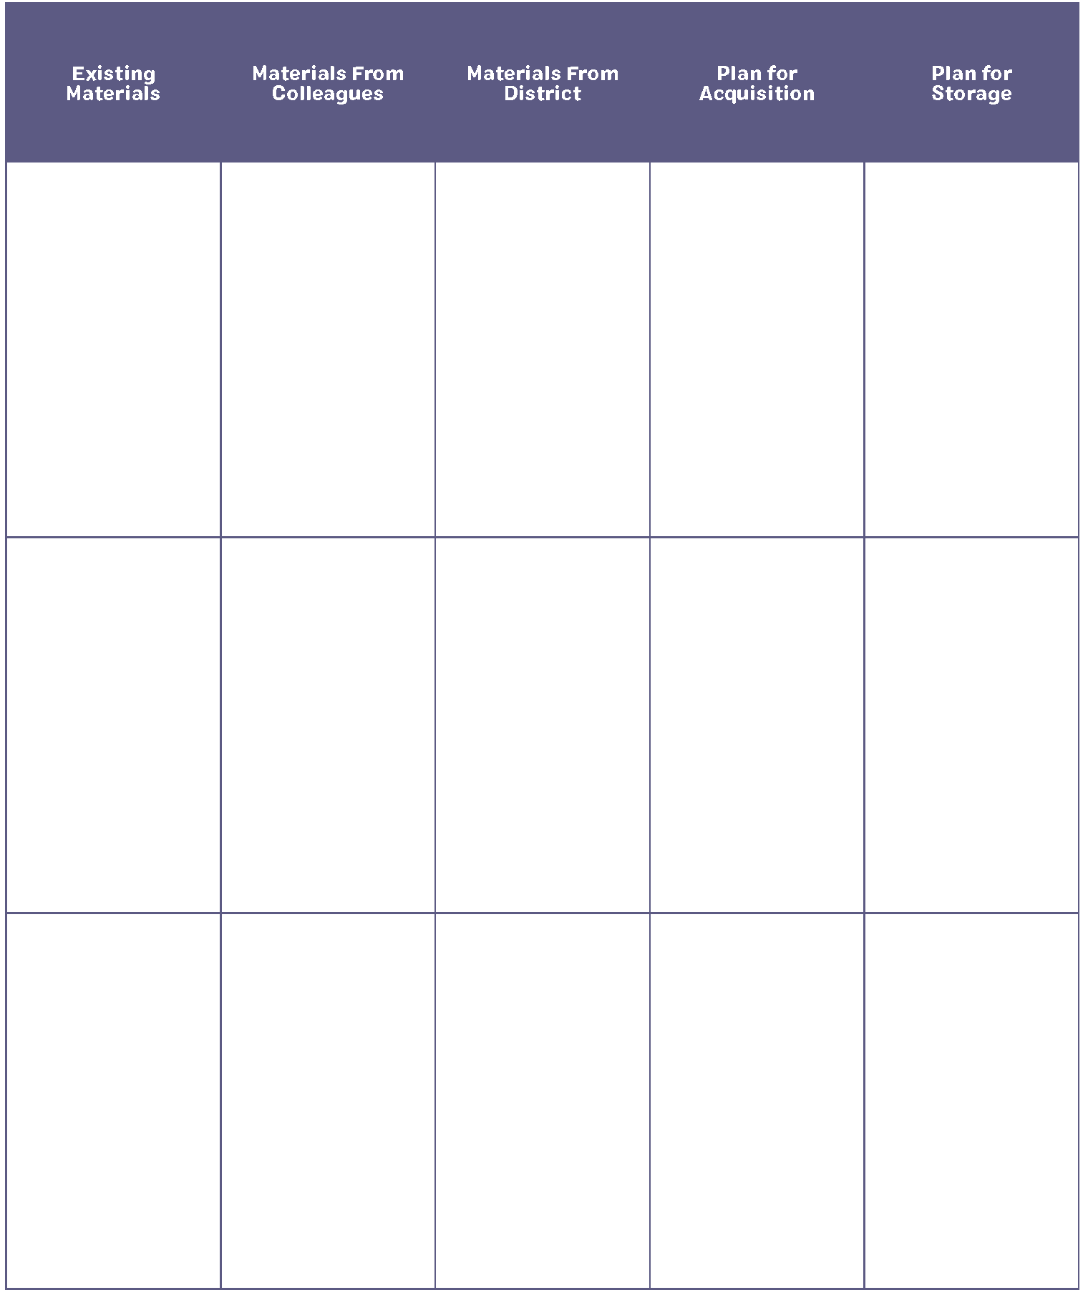

Retrieved from the companion website for Step Into STEAM: Your Standards-Based Action Plan for Deepening Mathematics and Science Learning, Grades K–5 by Sarah B. Bush and Kristin L. Cook. Thousand Oaks, CA: Corwin, www.corwin.com. Copyright © 2019 by Corwin. All rights reserved. Reproduction authorized for educational use by educators, local school sites, and/or noncommercial or nonprofit entities that have purchased the book.

